Abstract— Because of the constantly growing number of companies relying on the internet for their core business, network flexibility and security of their LANs have become essential for protecting companies data. From this need a Virtual Private Network (VPN) was conceptualized. So essentially, a VPN is connection of two or more LANs forming a secure and authenticated channel for data. At first, VPNs were implemented using more dedicated and more manageable channels such as ATM, Frame Relay, and switched networks. [1] Now, with the dominance of TCP/IP, VPN technology has been developed to also be implemented over a less secure and more public channel, such as a dial-up ISP connecting to the office LAN through the Internet.
Virtual Private Networks (VPNs)
(December 2002)
Alejandro Hoyos, David Regal, and Yu-Jung Ting
This paper will define a VPN, it’s the components, practical applications, and describes the most popular types. Because of the varied needs of the computer industry and network systems, when two VPNs are implemented, they can be made from very different components and standards. One way to analyze this topic is to explain the main requirements of a VPN for security and authentication, and the key features of each type.
Security, encryption, tunneling, firewalls, keys, and more, are all components of a good VPN. With these many different technologies, many different types of VPNs can exist, with many different implementations on different operating systems. To say the least, confusion can exist in such a diverse industry. To describe the best type of VPN, this paper will break down the basic technologies of a VPN, what software and hardware are needed for a VPN, and the most common VPNs. A sample implementation for Windows and an implementation for Linux will be described.
In this paper, protocols and specific vendors’ implementations of IPsec will not be covered in detail. For more on IPsec, see the RFC documents about IPv4 and IPv6. For vendor specific information, see the vendors’ website.

Index Terms— VPN, tunneling, IPsec, network, L2TP, Windows 2000, Linux.

INTRODUCTION

The world has changed a lot in the last couple of decades. Global markets have become important to most of the large and medium corporations. In order to spread out globally, the need to find a way to maintain fast, secure, and reliable communication for data is essential. This is where the virtual private network (VPN) comes into the picture of networking to fit their needs. Now, many companies are creating their own VPN to accommodate the needs of remote employees and distant offices.
The technical definition of a VPN is a private network makes use of the public telecommunication infrastructure, usually the Internet, to maintain privacy through the use of a tunneling protocol and security procedures. Instead of leasing a dedicated connection, a VPN uses virtual connections routed through the Internet from the party's private network to the remote site or employee. By applying VPN, a secure network of computers can use the Internet to share data by using tunneling protocols to protect it during transmission.

History
The technology for implementing VPNs has been in existence for some time. The beginning can be found in the Virtual Circuit. Virtual circuits are simple to implement in highly connected networks as well as being cost efficient. These benefits also apply to VPN as we will see.
The virtual circuit was developed in the late seventies and early eighties. A virtual circuit is a logical circuit created within a shared network between two network devices. This path may incorporate many hops between routers for the formation of the circuit. The final, logical path or virtual circuit acts in the same way as a direct connection between the two ports. In this way, two applications could communicate over a shared network.
Virtual circuit technology was then developed with concern over security issued by adding encryption equipment to router systems. This new method encrypted information between different ports of the virtual circuit, which was used to prevent attacker from getting data in transition.
Shortly after, other protection technologies were added. Unfortunately, the need for security issues increase as attackers skills advanced, which leads to the development of secure communication over a public network, a Virtual Private Network.

Analogy
As we mentioned before, VPN uses a tunneling protocol to ensure the security of the data being transmitted over the Internet. A good analogy to tunneling protocols would be to think the Internet as a bunch of computers connected by pipelines. When two computers wish to communicate between each other, one would send data through the pipeline to the other destination computer. The dilemma is that just about anybody can drill a hole into the pipeline and take a look at the information during the transmission of the data. Applying a VPN to such situation can prevent other from hacking into the data while it travels through the pipeline. A VPN create another pipeline or tunnel inside the bigger pipeline and make the link to the computer you wish to communicate with. At this instant, if the attacker wants to glance at your data, they not only have to drill through the first pipeline, but they have to drill through the second pipeline, which is made, analogously, of super strong titanium. In this case the connection between the two computers is made more secure.
An example of how a VPN is used, would be a large company based in a city that has some division offices located in a different part of country. Documents and information of the company are stored in the company headquarters are available by accessing the network at the headquarters while the other division office is not able to access the same data. One way to solve this problem while maintain the high security and effective cost is to set up a VPN to protect the data while it flows across the Internet. In this case the other division office is treated as if they are a part of the corporate office.
However, tunneling alone does not ensure privacy. To secure a tunneled transmission against interception, all traffic over a VPN is encrypted for safety. To overcome the security issue as we mentioned before, we may apply hardware and software to use tunneling protocols to create tunnels through the Internet, which will be explained in part of this report.

types of VPNs

There are many different types of VPNs. The consumers can make their choice between them based on their need. An inclusive list of categories is listed in this paper.

A. Router-to-router
Router-to-router VPNs use compulsory tunnels (defined later), which are established and maintained by the ISP point of presence.
1) VPN-on-demand tunnels: In this scenario, a VPN router would set up a tunnel between the two routers once a connection is made to a specific address. A tunnel is set up when the first connection is made. This tunnel carries on until the very last user disconnects. The comparison of this is that of traffic moving through a tunnel. The routers in the router-to-router tunnel must have compatible VPN capabilities such as key exchange and algorithm use.
2) VPN-on-demand multi-protocol tunnels: The routers in this type of VPN have a procedure that they follow when another protocol issues a connection request to a specific node on the other side of the IP network. A "transparent" connection must be established and the non-IP protocol tunneled to the remote site. In this situation, the VPN acts as though it is operating over an IP network.

3) VPN-on-demand Encrypted Sessions: In this implementation, each session is individually encrypted and the master session does not exist. This type of tunnel is easier to manage in than the master tunnel, but it involves a large overhead especially for highly connected applications between the same two sites.

B. Firewall-to-firewall
Firewall-to-firewall VPNs make use of firewalls on either end of the tunnel.

1) VPN-on-demand tunnels: These are very similar to the router-to-router connections described above; in addition, the network administrator can impose security rules and restrictions on the network users by using the firewall feature. The administrator can also perform auditing and traffic management in this implementation.

2) VPN-on-demand multi-protocol tunnels: similar to VPN-on-demand tunnels, but in this case the firewall should be able to handle multiple protocol filtering and security.

C. Client-initiated VPNs
Implementation of VPNs the tunnel management and encryption software is installed on the client system.

1) Client-to-firewall VPNs: The firewall implements a proxy facility that knows how the client connection should be handled. The client will then negotiate a VPN tunnel with the firewall over the IP network with the client software.

2) Client-to-server VPNs: This implementation provides end-to-end VPN services via a tunnel between the client and the remote server. The problems with this implementation are same as above, but the benefit is that the client can connect via any ISP, which will be oblivious to the tunnel.

High-level vpn structure
In this section, we will take a high-level look at VPNs. There are essentially three different corporate or business uses of VPNs: Intranet VPN, Extranet VPN, and Remote Access VPN. VPNs are used mainly in three internetworking scenarios. The dissimilarities between the types of VPN’s are the types of users they support.

A. Intranet VPN
Intranet VPN using VPN technology securely connects two or more trusted intranet within the organization through the shared Internet infrastructure. An example would be a network that exists in several buildings connected to a data center or mainframe that has secure access through private lines. Under this case, gateway routers or firewalls with VPN capabilities can be used to provide data authentication and encryption.

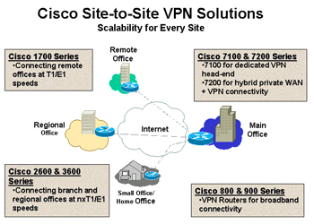
Source: Cisco Corp.

B. Extranet VPN
Extranet VPN provides links between customers, suppliers, partners, or communities of interests to a corporate Intranet over shared infrastructure using dedicated connections. Each group is allowed access to limited destinations within the network. The VPN network must be set up in a way that no data from a supplier will be visible to other suppliers or systems other than the wished-for destination.
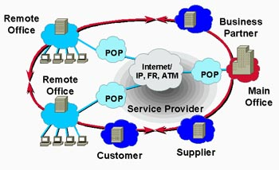
Source: Cisco Corp.

C. Remote Access VPN
Remote Access VPNs provide remote access to a corporate Intranet or extranet over a shared infrastructure with the same policies as a private network. This can be done by use of a VPN IPSec enabled remote client and firewall. The client accesses the Internet and then establishes an authenticated and encrypted tunnel between itself and the firewall at the edge of the network.

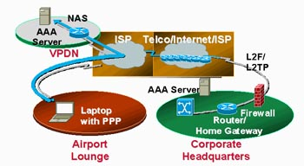
Source: Cisco Corp.

One of the most important concerns when designing VPN network is the number of clients will need to access the VPN network and the level of encryption (security) needed to be employed. To accommodate more users, higher encryption is needed along with enabled routers or switches.

In summary, as the VPN market develops and increases, the variations between a variety of categorizations and structural designs become rather indistinct. Hardware vendors are now offering features that were previously offered only through firewall-based solutions or software. Newer enhancements, such as Ipsec, make available a standard to create custom solutions.

Pros and cons

Advantages:
VPN is cost effective by eliminating the need for costly long-distance leased lines. By applying VPN to the network, companies only needs to have a fairly short dedicated connection to the network service provider.

VPN also provides privacy by password encryption and data encryption. Additional security may be obtained by encrypting the originating and receiving network address. Before the development of VPN, such security was only accessible through private networks.

Disadvantages:
Performance is a major concern to the VPN clients. For example, a connection to the company’s network through VPN is considerably slower than a typical connection. In addition sometimes, the availability and control of the VPN depends outside of the company’s control.

V. SECURITY

A. VPN Requirements

When implementing a Virtual Private Network there are several requirements that are needed to be met. The first one, which is the main purpose of a private network, is to facilitate controlled access to corporate resources and information. Since this information will be routed through a public medium the VPN must ensure the privacy and integrity of data as it navigates this medium. Therefore in order to provide a secure communication between stations VPNs should at least all provide user with:

AUTHENTICATION: [12] The VPN must be able to verify a user’s identity and restrict access to only validated users. In addition, there must be a method of logging access.

ADDRESS MANAGEMENT: [12] The VPN must be able to keep the IP addresses of the internal network secret.

DATA ENCRYPTION: [12] The data traveling on the public network must be unreadable by unauthorized users on the network.

KEY MANAGEMENT: [12] The VPN must be able to generate shared, secret keys with the remote users.

MULTIPROTOCOL SUPPORT: [12] The VPN must be able to handle multiple protocols so data of different types can be shared.

A well-designed VPN uses several methods for keeping your connection and data secure. Here we describe some of those methods.

B. Tunneling

Tunneling is a method use in an inter-network where you transfer data from one network to another. Instead of sending a frame as it is produced by the originating node, the tunneling protocol encapsulates the frame in an additional header. The additional header provides routing information so that the encapsulated payload can navigate the intermediate inter-network. After the frame has been encapsulated, it is routed to its destination over the inter-network.

Once it reaches its destination, the receiving station the frame is decapsulated and the information retrieved. Tunneling includes this entire process (encapsulation, transmission, and decapsulation of packets). Tunneling is essential for two reasons: First, it is able to transport multiple protocols over a single protocol network. Secondly, it has the ability to hide the source and the destination address. Typically the tunnel should be encrypted for security reasons.

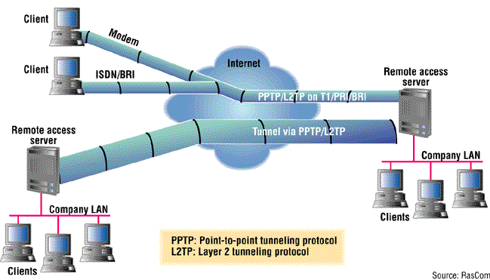
Figure 2

Tunneling can be done at any layer of the Open System Interconnection (OSI), seven-layer architecture for data communication over an IP backbone. Based on this the two most common layers used for tunneling are layer 2 (link layer) and layer 3 (network layer).

LAYER 2 TUNNELING
- Point-to-Point Tunneling Protocol (PPTP): [13] Created by the PPTP Industry Forum (US Robotics (now 3Com), 3Com/Primary Access, Ascend, Microsoft, and ECI Telematics).

- Layer Two Forwarding Protocol (L2F): [13] Created by Cisco Systems.

- Layer Two Tunneling Protocol (L2TP): [13] a combination of PPTP and L2F, which evolved through the IETF standards process.

LAYER 3 TUNNELING
- Multiprotocol Label Switching (MPLS)
- Internet Protocol Security (IPsec): [13] an architecture, protocol, and related Internet Key Exchange (IKE) protocol, which are described by IETF RFCs 2401-2409.

Tunnels can be created in various ways.
  - Voluntary tunnels: [14] A user or client computer can issue a VPN request to configure and create a voluntary tunnel. In this case, the user’s computer is a tunnel endpoint and acts as the tunnel client.
  - Compulsory tunnels: [14] A VPN-capable dial-up access server configures and creates a compulsory tunnel. With a compulsory tunnel, the user’s computer is not a tunnel endpoint. Another device, the dial-up access server, between the user’s computer and the tunnel server is the tunnel endpoint and acts as the tunnel client.

C. Symmetric Encryption
Symmetric, or private-key, encryption is based on a secret key that is shared by both communicating parties. The sending party uses the secret key as part of an algorithm operation to encrypt plain text to cipher text. The receiving party uses the same secret key to decrypt the cipher text to plain text. In order to for both stations to have the same secret key, the sending party has to transmit the key to the receiving party. The problem is that the transmission is done over a public medium which makes difficult to keep these keys confidential. [1] A technique called “key splitting” may be employed to reduce the potential of key disclosure during transit.

D. Asymmetric Encryption

Asymmetric, or public-key, encryption uses two different keys for each user: one is a private key known only to this one user; the other is a corresponding public key, which is accessible to anyone. The private and public keys are mathematically related by the encryption algorithm. One key is used for encryption and the other for decryption, depending on the nature of the communication service being implemented.

E. Certificates

With symmetric encryption, both sender and receiver have a shared secret key. The distribution of the secret key must occur before any encrypted communication. However, with asymmetric encryption, the sender uses a private key to encrypt or digitally sign messages, while the receiver uses a public key to decipher these messages. The public key can be freely distributed to anyone who needs to receive the encrypted or digitally signed messages. The sender needs to carefully protect the private key only.

Since there is a big demand for public keys, the public key is published with a certificate. [15] A certificate securely binds a public encryption key to the entity that holds the corresponding private encryption key. The certificate contains a series of values, such as the certificate name and usage, information identifying the owner of the public key, the public key itself, an expiration date, and the name of the certificate authority. [15] The most widely accepted format for certificates is defined by the ITU-T X.509 international standard.

F. IP Security (IPsec)

IP Security (IPSec) was designed by the IETF as an end-to-end mechanism for ensuring secure private communications over an IP network. With IPSec, only the sender and recipient know the security key. If the authentication data is valid, the recipient knows that the communication came from the sender and that it was not changed in transit. IPsec has two functions: data encryption and data integrity. IPsec uses two protocols to provide traffic security:

Authentication Header (AH): [17] provides connectionless integrity, data origin authentication, and an optional anti-replay service. It also includes a sequence number which allows the receiver to tell if the message has been modified.

Encapsulating Security Payload (ESP): [17] The Encapsulating Security Payload (ESP) protocol provides encryption, and limited traffic flow confidentiality. As AH, ESP also provides data authentication and data an integrity service, which makes it an alternative to AH.

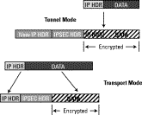

Figure 3 (© Cisco)

These new protocols are placed after the IP header in the frame. AH and ESP can work together or separately one is enough for most applications. They have no specific algorithm for encryption; they are open framework which allows industry to implement any mathematical encryption.

These two protocols can also be used in two modes of operation: transport and tunneling. When the protocol is set for transport, everything behind and not including the IP header is protected. One of the reasons that is done is because only a few bytes are added to the package. By not encrypting the IP the pubic network is able to see the packet source and destination. So it seems that transport mode is providing protection for the upper layer protocols. The problem with the transport mode is that hackers are able to monitor the packet traffic since the IP header is not protected.

When the protocol is set for tunneling mode, everything including the IP header is encapsulated in a new IP packet. [16] The major advantage of tunnel mode is that the end systems do not need to be modified to enjoy the benefits of IP Security. When using tunnel the problem of hackers monitoring packet traffic is no longer a problem since the IP header is also encrypted.

In order to use either transport and/or tunneling mode, both parties (source and destination) need to understand the IPsec protocol. Both transport and tunnel mode can be encapsulated in ESP or AH headers. Figure 3 shows the frame format of the transport and tunnel mode.

G. Key Management

Key management is required when the company is dealing with a large network. Since we need to distribute public keys to all the stations and the network is so large, a public key infrastructure is needed (PKI). The PKI will determine, distribute and track public keys and digital certificates. PKI is becomes very handy in large organizations that need to have a secure connection between office branches or employees that are traveling. There are two types of key management:

Manual: A system administrator configures manually every station with its own key and with the keys which that station is going to communicate with.

Automated: A system automatically issues keys for the stations that are going to be part of the network. Automated systems are the most flexible but require more software and are more difficult to configure.

H .Firewalls

A firewall provides a strong barrier between your private network and the Internet. You can set firewalls to restrict the number of open ports, what types of packets are passed through and which protocols are allowed through. However, firewalls do not protect you from attacks within the internal network. A firewall should at least have:

PACKET FILTERING: The headers of all network packets going through the firewall are inspected. The firewall decides if lets them pass or blocks them.

NETWORK ADDRESS TRANSLATING: Source and destination addresses in network packets are automatically translated back and forth by the firewall.

APPLICATION PROXY: The firewall is capable of inspecting the header of the network packets. This capability requires the firewall to understand the specific application protocol.

DATA CATCHING: Because the same data or contents of the same website may pass the firewall repeatedly in request to different users, the firewall can cache that data and answer more quickly without actually getting the data anew every time.

CONTENT FILTERING: Firewalls restrict access to inappropriate websites based on URLs, key words or content type.

INTRUSION DETECTION: Certain patterns of network traffic may indicate an intrusion attempt in progress. Not only blocks, but also disallows the senders IP address.
The most important piece of firewalls is the proper installation, configuration, and monitoring. If a firewall is improperly configured, you might be letting people in you thought you were blocking.
I. Authentication, Authorization and Accounting Server (AAA)
To properly administer a VPN system, network administrators should be able to track who uses the system, how many connections are made, unusual activity, and error conditions. AAA Servers are used for more secure access in a remote-access VPN environment. When a request to establish a session comes in from a dial-up client, the request is forwarded to the AAA server. AAA then checks the following:
  - Who you are (authentication)
  - What you are allowed to do (authorization)
  - What you actually do (accounting)
The accounting information is especially useful for tracking client use for security auditing, billing or reporting purposes.

VPN Implementations

The scenario of a small internet company

Let’s say an internet company, gatorco.com, has two offices. One in Gainesville, and one in Orlando. Both offices are of the same size and importance. The programmers, managers, and personnel of one office need full access to printers, tape backup drives, and servers of the other office. Keeping costs low is top priority because times are hard for upcoming technology companies.

The president has told you, the network administrator, to find the best VPN out there for the lowest cost. They also said use your judgment when considering security.
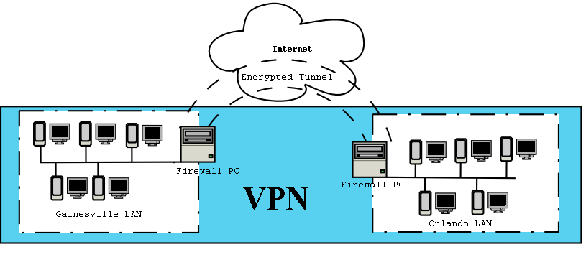
In considering implementations, only low-cost VPN software that is integrated into the operating system will be considered. Hardware devices exist for setting up a VPN, such as Cisco’s concentrators, and so do other vendor specific software (mostly likely expensive), but these will not be considered.

Note: The terms frequently used in technical papers – a gateway, client, server, host, machine, or box most likely mean a IBM compatible personal computer (PC). Networking is already very abstract, in order to give the reader a clear image of a physical hunk of metal, wires, and silicon contained in a gray case a foot and half tall, we will say Gainesville PC, gateway PC or client PC. This helps the reader to visualize, have a more concrete image, and to see there are physical parts to a network. This is used even though it is not technically a personal computer, PC, when it is a gateway or server, since there are many users and does not personally belong to one user (but maybe this could be said for all computers connected to a network).

Criteria for the best VPN
For selecting which implementation of a Linux VPN will be chosen, the following criteria is used:

Interoperatebility
The IPsec protocol should be followed closely. This eases the connection of one type of VPN to another.

Security
If the first criteria was meet, then this should follow. However, in implementations VPNs, IPsec is not used or it is used in a non-standard way. Then the security of each type must be evaluated individually.

Low cost
Gatorco is a small business and cannot afford expensive software or specialized VPN hardware.

Help is out there - Actively supported by the authors of the technology
Updates to the program, a dedicated website, and installation instructions are vital to the person in charge of setting-up and maintaining the VPN.

TYPES OF Implementations for Linux
All of the following is a compilation from references [2]-[4].

Linux to Windows 2000

L2TPd (hybrid IPsec because of the Windows 2000 side)
Pro:
- Network to Network
- Linux daemon (a daemon is program that runs in the background)
Con:
- Transport Mode of IPsec because Windows 2000 only uses Transport Mode.
- Non IPsec

FreeS/WAN with VPN tool (IPsec: Marcus Müller's Windows 2000 VPN Tool at http://vpn.ebootis.de
Pro:
- Inherits security from FreeS/WAN and Linux
- Connects with Windows 2000 client
Con:
- Not widely used so harder to find help

Linux to WinNT through NT’s PPTP and RAS (non-IPsec)
These implementations are not recommended because of the poor security of Microsoft’s PPTP.

PoPTop

Zebedee

PPTP-linux native

Linux to Linux (IPsec)
To use a true IPsec implementation, and if a firewall is installed that uses Network Address Translation (NAT), care must be taken to insure the tunneled packets are not passed through NAT. This is because after IPsec performs its checksum encryption, IPsec protocol does not allow any changes to the source or destination header fields. This is exactly what NAT does to hide the internal network addresses. To fix the problem, the packets destined for the VPN tunnel must bypass the NAT part of the firewall. [2]

FreeS/WAN
Pros:
- Actively supported and has many help pages are available.
- Can connect to client and gateway Windows 2000 and WinXP as well as other Linux computers.
Cons:
- Have to reconfigure firewall if NAT is used or want to place the FreeS/WAN computer behind the firewall.

Pipsecd

NIST cerebus

ipnsec
By Peter Novak. Uses Photuris for key management.

KAME
Pros:
- connected well with other IPsec Implementations
Cons:
- Native to Unix so has to be translated to the Linux environment.
- Not actively supported.

Linux to Linux (non-IPsec)

CIPE
Pro:
- Lightweight so doesn’t load the computer down
- Actively supported.
- Does not require reconfiguration of firewall and NAT.
Con:
- Not IPsec

vpnd
Pro:
- Daemon that uses Blowfish for encrypted tunnels.
Con:
- Non IPsec

Tinc
Pro:
- Linux daemon.
Con:
- Non IPsec

EN skip
Pro:
- Sun’s SKIP protocol.
- Works well with a Linux/Unix environment
Con:
- Non IPsec

The decision for Linux– FreeS/WAN
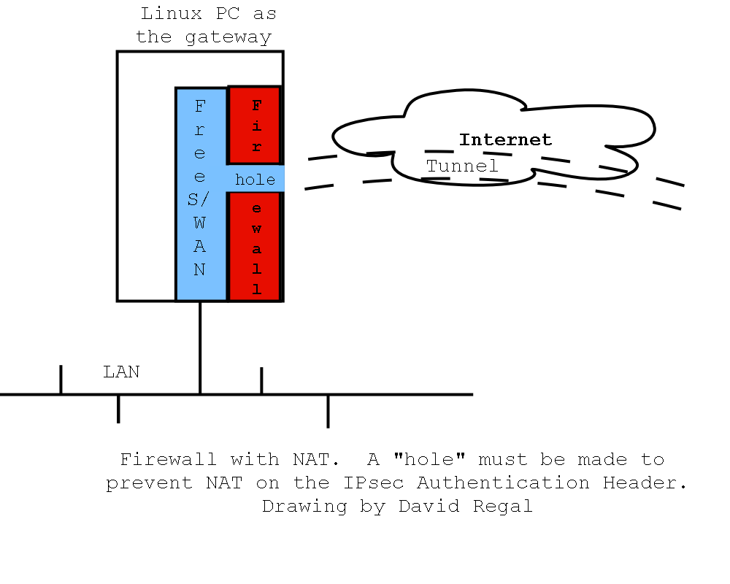
After considering the pros and cons for all the types of implementations and looking at interoperability tests on the HCS website, FreeS/WAN is the best choice for adhering to the IPsec standard, being low cost, and ease of use. According to HCS, it was the only openSource that was compatible with all the other IPsec VPNs under testing. [5]
A confirmation of this choice was found at InformIT.com. [6] When researching for the best of the choices of VPN implementations, the search string of “best VPN” was used. So no bias in favor of one implementation or another was in the search.
FreeS/WAN version 1.91 with the patch X.509 v0.9.12 or higher is what should be used for gatorco.com.

implementation of FreeS/WAN for Linux

Linux network architecture and requirements
For the company gatorco, a firewall-to-firewall architecture will be used. The two computers both have Linux operating systems, but Window computers may be used within the LAN.
Hardware and software requirements are [6]:

Two Linux PCs as gateways with static IPs. Both with a network behind them. Debian distribution of Linux is used for this example.

FreeS/WAN (version 1.91 or better)

X.509 patch for FreeS/WAN (version 0.9.12 or better)

OpenSSL (for creating certificates)

Tcpdump (program for testing the gateways)

Checklist to setting up the Linux VPN
The following steps are a compilation of references [6] and [8]. Since there are many different how-to documents, and instructions provide with the programs, this is suppose to provide the overall view of what is happening when setting up the network. When reading all the different resources, it is easy to become lost in the details. Using the main steps and clear English, we hope to clear up the process. For the more, please see the references [6] and [7].
In the instructions, the company Gatorco owns static IP address for both its Gainesville PC and Orlando PC. They are both gateways for the networks (i.e. LANs) that lie behind them.

Download the software on both Linux

Install FreeS/WAN and the X.509 patch.

On the Gainesville PC, set up a Certificate Authority using OpenSSL

Use the command:
$/usr/lib/ssl/misc/CA.sh -newca

On the Gainesville PC, create a certificate for the Gainesville PC using OpenSSL.

Type the command:
$/usr/lib/ssl/mis/CA.sh -newreq

This will create two files. A complete certificate is made up of two parts – a public key (the file called newcert.pem ) and a private key (file called newreq.pem). Both are ASCII files that contain the RSA encryption key. By default, OpenSSL creates a 128-bit key and gives it 1 year before expiring. Both of these can be changed in the /etc/ssl/openssl.cnf file. This is the directory for Debian Linux. The directory may be different on other distributions.

On the Gainesville PC, rename the files newreq.pem and newcert.pem

On the Gainesville PC, edit the setup files for FreeS/WAN program.

With a text editor, open the /etc/ipsec.secrets file for editing, the $password that was given in step 4 is kept here. Add a line like:
: RSA careq.pem “$password”

In the /etc/ipsec.conf, change the fields so the right signature key is the OrlandoPC, and the left signature key is the Gainesville PC.

On the Gainesville PC, create a certificate for the Orlando PC using OpenSSL.
Again, using the command:
$/usr/lib/ssl/mis/CA.sh -newreq

On the Gainesville PC, copy the certificatefiles over to the Orlando PC.

On the Orlando PC, move the files to the appropriate locations

On the Orlando PC, edit the setup files for FreeS/WAN program

Similar to previous step, but left signature key is now Orlando (local), and right signature key is Gainesville.

On the Orlando PC, start the VPN connection

Use the command:
$ipsec auto --up gainesvilleconn
where gainesvilleconn is the connection name found in the /etc/ipsec.conf file.

The two networks should now be linked in a VPN.

Types of Windows Implementations

WinNT server to Win98/WinNTclient using PPTP (non IPsec)
In this configuration, the server and the client use the Microsoft proprietary protocol, Point-to-Point Tunneling Protocol (PPTP) with the server’s Remote Servers (RAS). This implementation is not recommended because it there are many known hacks for PPTP, simple hashing for password, simple keys, does not authenticate control traffic, and is not interpretable with IPsec. [9]

Windows 2000 server to Windows 2000/WinNTclient/Win98 using L2TP/IPsec hybrid (limited IPsec – only supports Transport Mode)
L2TP stands for Layer 2 Tunneling Protocol. Unfortunately, Microsoft parted from the standard because of wanting backwards compatibility with the Win98/WinNTclient PPTP. But the L2TP/IPsec software in Windows 2000 is a good choice since it comes with Windows 2000 and has a large support base. If the PPTP options are disabled, the security is an improvement from the Windows NT’s RAS. [9]
Another disadvantage is an added payload of 40 to 50 octets per packet is added because of the L2TP. [10]

The Decision for Windows – Windows 2000
Since the options are limited, this choice was not difficult. The most secure and the closest to IPsec is Windows 2000. Of course, there are other implementations of Windows, but we only considered the most common two.

Implementation of Windows 2000
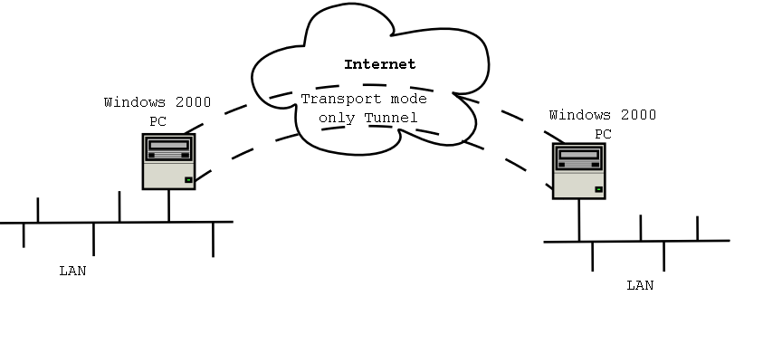

Windows network architecture and requirements [11]

Windows 2000 PCs with static IP addresses

Windows 2000 Server as a domain controller
This VPN implementation will also be a firewall-to-firewall architecture.

Checklist to setting up the Linux VPN
The following is from trial and error. Also, Microsoft provides a long explanation of Windows 2000’s L2TP/IPsec and how to configure it. [11]

On the Gainesville PC using the Microsoft Management Console (MMC):

Click on Control Panel Network and Dial-up Connections

Select Make New connection

Open the RRAS snap-in
RRAS is the replacement for the old RAS in WinNT. The snap-in tool is also available for WinNT.

Right click your server
A setup Wizard should appear.

Choose Manual installation

Disable PPTP
Win98 clients will not be able to connect.

Enable L2TP traffic

Do the some changes to the filter settings to allow access to webpages
That is, by default the filter restricts traffic to only L2TP or PPTP. Therefore, if access to the internet is wanted, the default filters will have to be changed.

Repeat steps (1) through (8) for the Orlando PC

On the Orlando or Gainesville PC, click on the Network and Dial-up Connections icon that was created.
The two networks should now be linked.

CONCLUSION

VPNs allow users or corporations to connect to remote servers, branch offices, or to other companies over a public inter-network, while maintaining secure communications. In all of these cases, the secure connection appears to the user as a private network communication despite the fact that this communication occurs over a public inter-network. VPN technology is designed to address issues surrounding the current business trend toward increased telecommuting and widely distributed global operations, where workers must be able to connect to central resources and communicate with each other.
References
- ADTRAN (Specific author unknown), Understanding Virtual Private Networks. ADTRAN Inc. [online] http://www.adtran.com
- LinuxSelfhelp (2002) LinuxSelfhelp.com. http://linuxselfhelp.com/HOWTO/Networking-Overview-HOWTO-8.html#ss8.13
- Arpad Magosanyi . The VPN HOWTO, v0.2,7 Aug1997 v0.3, 2001-12-01 http://www.ibiblio.org/mdw/HOWTO/mini/VPN-8.html#ss8.1
- FreeS/WAN. Web links. http://www.freeswan.org/freeswan_trees/freeswan-1.99/doc/web.html#linuxipsec
- HSC. IPsec 2001 Interop Demo. 5 November 2001. http://www.hsc.fr/ressources/ipsec/ipsec2001/index.html.en
- Brian Hatch, Oleg Kolesnikov MAR 15, 2002 Linux VPN Fundamentals InformIT.com http://www.informit.com/content/articlex.asp?product_id=%7B77F0A3E1-F6FA-44DB-B3D8-7086520540BA%7D&element_id=%7B05FD673E-3C1C-4049-B925-A800071BE902%7D&st=B4A53C57-EE2E-4A5C-B77B-40730C78B24A
- FreeS/WAN. Introduction to FreeS/WAN http://www.freeswan.org/freeswan_snaps/CURRENT-SNAP/doc/config.html
- University of Westen Austrailia, Computer Science department. Creating certificates. http://www.cs.uwa.edu.au/~ryan/tech/certificates.html
- Maureen Adams, Security Complete (book style). Alamed, CA: SYBEX, 2002, pp. 386-387
- Lisa Phifer, Mar 27, 2000 Window 2000's VPN-Related Security Issues. http://www.isp-planet.com/technology/vpn_windows2000a.html
- Microsoft. Step-by-Step Guide to Internet Protocol Security (IPSec). February 17, 2000. Microsoft http://www.microsoft.com/windows2000/techinfo/planning/security/ipsecsteps.asp
- Merkow, Mark S. Virtual Private Networks for Dummies.
- Microsoft. Virtual Private Networking and Intranet Security. © 1999 Microsoft. [Online]. Available: http://www.microsoft.com/windows2000/techinfo/howitworks/communications/remoteaccess/nwpriv.asp
- Stede, Mathew. Network Security Jumpstart.
- 2002 SYBEX Inc. 1151 Marina Village Parkway, Alameda CA 94501.
- Certificates. (C) 2001 Microsoft Computer Dictionary. [online]: http://www.microsoft.com/windows2000/en/server/help/default.asp?url=/windows2000/en/server/help/sag_CMIntroCerts.htm
- IPsec overview, from Cisco. Posted: Tue Nov 21 14:03:38 PST 2000. All contents copyright © 1992--2000 Cisco Systems, Inc. [online]: http://www.cisco.com/warp/public/cc/so/neso/sqso/eqso/ipsec_wp.htm
- R. Atkinson and S. Kent, Security Architecture for the Internet Protoco.November 1998. [online]: http://www.ietf.org/rfc/rfc2401.txt?number=2401
- Cisco Corp. Virtual Private Network Design [Online]. Available: http://www.cisco.com/warp/public/779/largeent/design/vpn.html
- Virtual Private Network [Online]. Available: http://www.kampsight.com/Computer_Definitions/VPN.html
- I. Davis, “History of VPN,” [Online]. Available: http://people.cs.uct.ac.za/~idavies/Security/
- Introduction to VPN [Online]. Available: http://compnetworking.about.com/library/weekly/aa010701c.htm
- Virtual Private Network [Online]. Available: http://www.avalontc.com/networking/prosconsVPN.htm
- Virtual Private Networking (VPN) Security (White Paper) Last Updated: Friday, July 13, 2001. © 2002 Microsoft Corporation. All rights reserved. [online]:
- http://www.microsoft.com/ntserver/techresources/commnet/VPN/VPNSecurity.asp

 

