Practical Voice over IP (VoIP) with OpenH323
The PhoniGators Project
By
David Regal (dcregal@hotmail.com)
Electrical engineering undergraduate
University of Florida

This report is submitted in partial fulfillment of the requirements for Highest Honors (Summa Cum Laude)

Spring Term 2003

1 Concept and specifications of the VoIP system 1
1.1 Concept 1
1.2 Specifications given by Dr. Latchman 1
2 Research 1
2.1 SIP or H.323? H.323 was chosen 1
2.1.1 Session Initian Protocol (SIP) 2
2.1.2 H.323 protocol 2
2.2 Windows versus Linux – Windows was chosen 2
2.3 Hardware – bought 2 ISA LineJACKs from Quicknet 2
2.3.1 Negatives of the PhoneJACK card: 2
2.3.2 Negatives of the LineJACK card: 2
2.3.3 Positives of using a LineJACK or PhoneJACK card instead of a sound card [2]: 3
2.3.4 Alternatives to LineJACK 3
2.3.5 Email the OpenH323 community (see Appendix A) 3
3 Diagram of our test system 3
3.1 Diagram and steps of a remote call 3
3.2 Potential challenges, concerns and answers 4
4 Programs and libraries used in the OpenH323 software suite 5
4.1 OpenPhone program ( version 1.8.1 ) 5
4.2 OhPhone program (version 1.3.7) 5
4.3 PSTNgw program (version 1.2.2) 5
4.4 OpenH323 library (version 1.11.4 according to CVS tag ) 6
4.5 PWLib library ( version 1.4.8 according to CVS tag ) 6
5 Three phases for testing the Phonigator system and schedule 7
6 Results from testing in the Communications Lab 8
7 Planned steps for finding a solution and fixing the problem 9
7.1 Email the OpenH323 mailing list 9
7.2 Research the internet for examples 10
7.3 Determine if the correct LineJACK driver from Quicknet was installed 10
7.4 Test PSTNgw with a incomnig H.323 call from OpenPhone 10
7.5 Under VC++, compile PWLib, OpenH323, and PSTNgw with no modifications 10
7.6 Compile with modifications under VC++ 11
7.6.1 Add to code so trace (debug output file) will output even more 11
7.6.2 Obtain the latest LineJACK driver (ixjwin32.cxx) file from the CVS repository and compile into the OpenH323 library. 11
7.7 Test on Linux with lastest LineJACK driver 11
7.8 Start programming: Modify code and debug all the files on Windows 11
8 Communications Lab - Testing H.323 call to PSTNgw 11
8.1 Results – success [fig. 4] 11
8.2 Theory why PSTNgw fails on incoming PSTN calls – Centrex phone system 12
9 Testing the system at an apartment 13
9.1 Testing PSTNgw to OpenPhone 13
9.2 Results – success [fig. 5] 13
9.3 Conclusion 14
9.3.1 Next step – move to a place with two phone lines 14
9.3.2 Why not separate the PCs? 14
10 Testing at a house with 2 phone lines 15
10.1 Testing PSTNgw to PSTNgw 15
10.2 Results –fails to dial out 90% of the time [fig. 6] 15
10.3 Testing OpenPhone to PSTNgw 15
10.4 Results – also fails to dial out [fig. 7] 16
10.5 Conclusion – PSTNgw program works but not with AM interference 16
11 Back to the apartment – testing with 2 phone lines 17
11.1 Testing PSTNgw to PSTNgw 17
11.2 Results – success [fig. 9] 17
11.2.1 Tested successfull several times – PSTNgw is bidirectional 18
11.2.2 Soft conversation - Volume needs to be turned up 18
11.2.3 PSTNgw will lock-up if ”#” not pressed 18
11.3 Conclusion –need clean phone lines 18
11.3.1 No noise 18
11.3.2 No switching 18
11.3.3 Sensitivity to the above may be a programming problem or LineJACK hardware problem 19
12 Future plans 19
12.1 Use this VoIP system to test different codecs 19
12.2 Purchase credits and test InternetSwithboard 19
12.3 Seperate the computers and test across the Internet 19
12.4 Compiling and modifying the OpenH323 souce code 19
12.4.1 Current Versioning System (CVS) repository can be used 19
12.4.2 Add more digits 20
12.4.3 Implementing in other countries 20
12.5 Converting to Linux 20
12.5.1 Same OpenH323 programs available 20
12.5.2 Linux version of PSTNgw program is possibly more stable 20
12.5.3 Using Linux version may fix sensitivity problem 20
12.6 Converting to a SIP based system 20
12.6.1 More PCs required 21
12.6.2 Try to use the program VOCAL www.vovida.org [6] 21
13 Conclusion 21
13.1 OpenH323 is a solution to a PSTN to PSTN VoIP system 21
13.2 PSTNgw performs all of the required specifications 21
13.3 Business theory and lessons learned 21
14 Acknowledgements 22
14.1 Dr. H. Latchman 22
14.2 PhoniGators team 22
14.3 Professors on my Highest Honors (Summa Cum Laude) committee 22
Appendix A – email about POTS vs PSTN port on LineJACK, modem/sound card alternative 24
Appendix B – long email about switching problem 29

ABSTRACT

Beginning in January of 2003, a Voice over IP (VoIP) project was suggested by Dr. Haniph Latchman for the class he was teaching, Computer Communications. The idea he saw was for a “remote call-in system” that would be started with this project and continue on to a product for low-cost long distance calling. After obtaining the specifications, I and four others students from the Computer Communications class went on the task of researching for a solution. This report includes the research was done, the decisions made for the type of hardware used, documentation of the programs used, test configurations, results from the tests, and the lessons learned.

Ultimately, the desired a VoIP system is a simple desktop box that can call into a server for low-cost long distance phone calls. For the start of this vision, this project will be two computers with two VoIP cards used to make a remote call through the Public Switched Telephone Network (PSTN) and routed through a LAN to the other computer which will then go back to PSTN. This is not the final product but a controlled test environment.

When appropriate, credit is given to the members of the PhoniGators group for their research. This report will supplement our work and can be used in future VoIP projects.

Concept and specifications of the VoIP system

Concept
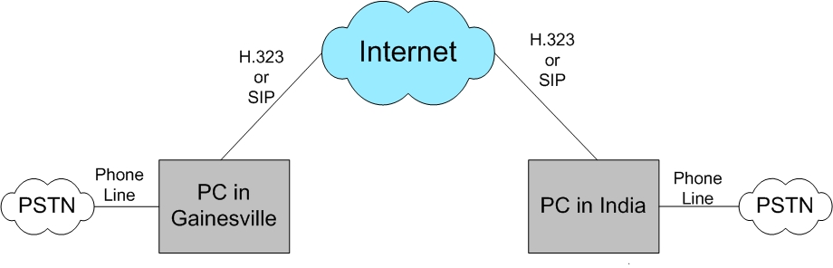

[fig. 1-1] Making a long-distance phone call through the Internet

Specifications given by Dr. Latchman
- Want ability to have more than 10 digit dialing (352 338-9999) for the 2nd number. No more than 10 digits for the PhoniGators project, but look for how to program this option.
- If the 2nd number is wrong, no attempt for error correction. Just reset and prompt user to enter the number again.
- Prompt for the 2nd number will be a simple dial tone. No voice (.wav file, etc.) for now but should keep the option in mind for future.
- Control of the signaling – ring, busy signal, call waiting
- Ultimate product is to be an easy to use desktop VoIP box that calls into a server for low-cost long distance calls.

Research

SIP or H.323? H.323 was chosen
These are two protocols for VoIP. Both the telecommunication side and the networking side have their preferences, and thus two protocols have been created. The H.323 works closer with the telecomm side and SIP is very similar to HTTP. Even though one can be used in the place of the other, the two protocols can be used together.

In the project “Experimenting with New Methods in Voice over IP”, the group made a system with SIP on the inside and used H.323 at the endpoints. However, the simplest approach is to just use one protocol. H.323 was chosen because it is easier to interoperate with PSTNs, there are several open-source programs from OpenH323 available, and the drivers have been developed to work with the LineJACK cards (VoIP cards). [1]

Session Initian Protocol (SIP)
Benefit is it has is simplified protocol but becomes more complex when an all-in-one PSTN to PSTN network is desired. For administration of the system such as bandwidth control, account information, and billing, SIP requires extending the basic protocol.

For open source SIP based software, down VOCAL available from www.vovida.org. As of the time of this writing, it is only available for Linux [2].

H.323 protocol

OpenH323 software suite and source code is available for both Windows and Linux at www.openh323.org. So if the project is done successfully in a Windows environment, then transporting the system to Linux should be possible because the same programs can be used.

Windows versus Linux – Windows 98se was chosen
Windows was chosen since it was more familiar to the entire group. If we used Linux, more time would be spent learning Linux, than would be spent on the project itself.

Hardware – bought 2 ISA LineJACKs from Quicknet

Negatives of the PhoneJACK card:
- Can not do a remote call. Only an analog phone connected on-site (this is their version of POTS). Need LineJACK for this.
- Cost $150
- Want to use the program OpenPhone but it may not take advantage of the DSP, compression/decompression that is on the PhoneJACK card. If it doesn’t, then the PhoneJACK is just a soundcard with a POTS port for an analog phone.
- One advantage to having the PhoneJACK is you can use a regular telephone which more people are comfortable with.
- However, using an analog telephone through the PhoneJACK’s POTS port is not a clear as using the PhoneJACK’s microphone and headset ports.
- If you’re on site, why not just use a microphone and headset through a sound card? Use software such as MS NetMeeting, MSNmessenger, Net2Phone, or OpenPhone. No need for a PhoneJACK card.

Negatives of the LineJACK card:
- Cost. At $300 per card, the total is $600 total. This is a lot of money to risk on a research project that may be unsuccessful.
- If successful on implementing a remote call with the OpenH323 software, how can this be put into a low-cost VoIP box that anyone can use?
- The program OpenH323 PSTNgw is still under going development. From studying the readme.txt and online documentation, Voicetronix seems to have been tested and guaranteed to work with the OpenH323 PSTNgw but not the LineJACK. [1]

Positives of using a LineJACK or PhoneJACK card instead of a sound card [2]:
- Reduced delay (lag). Over-all better voice quality.
- Echo cancellation
- On card DSP and compression/decompression offload processing from CPU of the computer
- Full duplex – talk and listen at the same time. Sound cards can’t do this usually.
- Pre-licensed codecs
- Sound cards can’t generate dial tones, and other control signals like a phone system

Alternatives to LineJACK
With a full-duplex sound card (one with 2 in and 2 out ports) and modem, it is possible to replace the functionally of the LineJACK card. Also, most soundcards have both G.711 and G.723 codecs. [3]

However, could this be done in the amount of time allowed and with the programming talent available? An email would be sent out seeking advice from those interested in the VoIP.

A competitor to Quicknet, VoiceTronix offers several VoIP cards with multiple PSTN ports but are more expensive and do not have functional programs for their cards like Quicknet. So programming would be needed for these cards.

Email the OpenH323 community (see Appendix A)
To clear up some questions that remained after reading through the OpenH323 documentations and looking through the Q&A archives, the OpenH323 community was emailed at openh323@openh323.org. This is not just developers under the OpenH323 project, but a worldwide community of ranging from telecomm professionals to experienced programmers not affiliated with OpenH323 or Quicknet.

Three responses came – one not helpful from a developer at OpenH323 or OPAL, a good one explaining the difference between the POTS port and PSTN port (this is difference between LineJACK and PhoneJACK card), and lastly, a good one from a PhD professional in the telecommunications industry.

To summarize their answers, to develop a sound card/modem system is not practical since the time and resources put into it would eventually cost more than to buy a VoIP card. LineJACK is the best choice since drivers have already been developed and licensed voice codecs are bundled into its onboard chips. Appendix A contains the email and their responses.

Diagram of our test system

Diagram and steps of a remote call
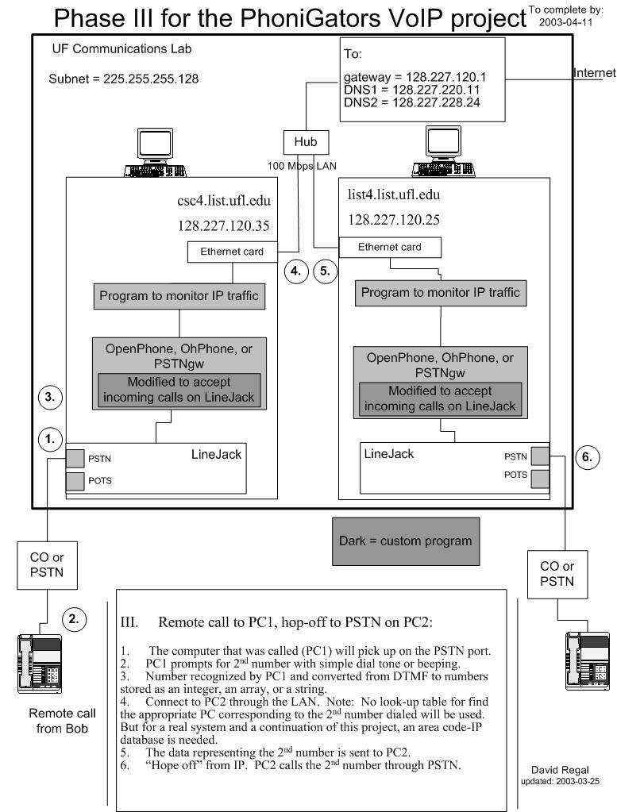
s/n: 355c047e
s/n: 355c0410
[fig. 2] Remote call on left-side is transferred to phone on the right-side

Potential challenges, concerns and answers
- How many specification requirements can the PSTNgw program fulfill without modification?
- Having second number passed to PC2
- Versions of LineJACK drivers that were download from Quicknet may not be the same ones used by OpenH323
- Tracking changes and debugging could be difficult if more than 2 are programming (if programming needed)
- OpenH323 programs are mostly undocumented so have to learn by trial and error or reading the source code
- Scalability is costly since there is only one PSTN port for one LineJACK card
- Quality of Service and security are ignored since we are working in with a LAN instead of the Internet

Programs and libraries used in the OpenH323 software suite

OpenPhone program ( version 1.8.1 )
OpenPhone is a GUI H.323 client program. It is only available for Windows. The user-friendly interface has many features. For instance, you can set speed dial keys. If you’re using a LineJACK or PhoneJACK card, you can simply press one button and the “#” key to dial the IP of another computer that accepts H.323 calls.

A H.323 client is basically a way to have PC to PC audio or video conversations over a LAN or Internet. You have to know the IP of the PC you want to call and be by your computer to speak into the microphone. This program is similar to MS NetMeeting or Gnomemeeting.

Debugging would be difficult since trace has little information. When running the program with the “trace” option on (trace creates a text file for debugging), OpenPhone provides little information for insight into what is happening in the program. However, since OpenPhone worked on the first try, there is no need for debugging, but it would be nice to use the trace output file for reference of a working H.323 call.

OhPhone program (version 1.3.7)
This program is available for both Windows and Linux. Also a H.323 client, but command line instead of GUI. Since it is not a GUI, knowledge of the syntax to run the program is needed. But compared to pstngw.exe, it is simple to learn and only a few arguments are needed to make a call to another computer that accepts H.323 calls.

PSTNgw program (version 1.2.2)
Main program used to for any system that will be making or accepting calls from the PSTN (Public Switched Telephone Network) and converting the PSTN call into H.323 format. Even though it has been claimed that this program should work with LineJACK, PSTNgw from OpenH323 has not been guaranteed or tested to work with these cards.

Syntax for this program is cryptic at first, and the readme.txt (with outdated commands) provides little help for the argruments that are needed by the options. If you try to view the help output (“pstngw.exe –h”) from a MS-DOS shell, it flies off the top of the screen and you’ll only see the last part of it. To capture the whole output, at the DOS prompt type:

pstngw.exe –h | MORE > pstnhelp.txt

Open the “pstnhelp.txt” text file that was created in the current directory and you’ll have the commands (updated) for the version of PSTNgw you are using. This can also be used to redirect the screen output as the PSTNgw program is running.

Even with the up-to-date commands from the help output, it is hard to determine what the syntax is for a basic set-up. After looking through the source code and researching the archives of the OpenH323 mail list, the syntax for using a LineJACK card (syntax for Linux is different) was discovered [4]:

-q serialNumberOfLocalLineJACKCard IPofRemotePCacceptingH323calls –i bindToIP

So to make a call to 128.227.120.35 from 128.227.120.25, use the command:

pstngw.exe -q 355c047e 128.227.120.35 -i 128.227.120.25

This will allow incoming PSTN calls to come into 128.227.120.25, and be transferred to 128.227.120.35 as a H.323 call. Using Notepad or other text editor, save your frequently used commands as a .bat file and you can simply double-click the .bat file to run the PSTNgw program. Be sure to save the .bat file in the save directory as the PSTNgw program.

The serial number of the LineJACK is found on the anti-static wrapper of the bag it came in, or on a white sticker on the card. If you still can’t find it, go to Quicknet.com and look for help on their website.

For examples of the PSTNgw commands, see the boxes above the computers in the figures.

OpenH323 library (version 1.11.4 according to CVS tag )
Project OpenH323 starts here. Whenever a program is developed, this is the library that is used. So all of the OpenH323 programs require this dll (dynamic link library), or the equivalent static library.

Looking at the source code, this is where functions for the LineJACK card and other VoIP cards (LID cards) are found. For example, the file openh323/src/ixjwin32.cxx contains the functions for testing if there is a dial tone, if the phone is ringing, if PSTN disconnected, etc.

If something is not working for the PSTNgw, it might be because the library functions for the VoIP cards are incorrect or there is a driver mismatch.

PWLib library ( version 1.4.8 according to CVS tag )
PWLib stands for Portable Windows Library. First started just to provide conversions between Linux and Windows, it is now used for other purposes such as providing a way to create and control processes in the C++ language. For example, whenever PProcess:create or the like is seen, look to this library for how the function is working.

Also a dll that is required for the OpenH323 programs to run. Instead of being a dynamic library, it also can be compiled as a static library but the appropriate changes to OpenH323 need to be made.

Three phases for testing the PhoniGator system and schedule
March 21, 2003
- Test hardware. On site PC to PC call (no programming):

phone at PC1 - - LAN - - phone at PC2

- Set up the IP addresses in Windows 98 and the OpenH323 software.
- From PC1, dial PC2 using touch pad on the phone or the software.
- Two phones connected to the computer through the POTS port. Most of the software will already do this.

March 28, 2003
- Test PSTNgw. On site call to PC2 (programming expected*):

Remote call → PSTN - - PC1 - - LAN - - PC2 - - phone at PC2

- The computer that was called (PC1) will pick up on the PSTN port.
- Connect to PC2 through the LAN. Using OpenPhone on PC2, the phone connected to the POTS line on PC2 will be rung. This is an on-site call similar to Phase I.
Note: No 2nd number will be entered. PC1 will not prompt for a 2nd number.

April 11, 2003
- Test the full system. Hop-off at PC2 (programming expected*):

Remote call → PSTN - - PC1 - - LAN - - PC2 - - PSTN → remote phone

- The computer that was called (PC1) will pick up on the PSTN port.
- PC1 prompts for 2nd number with simple dial tone or beeping.
- Number recognized by PC1 and converted from DTMF to numbers stored as an integer, an array, or a string.
- Connect to PC2 through the LAN. Note: No look-up table for find the appropriate PC corresponding to the 2nd number dialed will be used. But for a real system and a continuation of this project, an area code to IP look-up table is needed.
- The data representing the 2nd number is sent to PC2.
- “Hope off” from IP. PC2 calls the 2nd number through PSTN.

*Note: Programming is said “expected” since as the time of writing the above schedule (written sometime around March 3), the LineJACK cards and OpenH323 programs have not been tested. If all the programs work and provide all the features needed, then no programming will be needed.

Results from testing in the Communications Lab
Phase I: phone at PC1 - - LAN - - phone at PC2
Status: Success
Means: LineJACK cards are good, LineJACK drivers were installed correctly, and PCs networked together properly.

Phase II: Remote call → PSTN - - PC1 - - LAN - - PC2 - - phone at PC2

Status: Fails, but comes closer to completing H.323 call than Phase III
Means: Some programming needed. Going to jump to Phase III since it is more important.
Problem: Fails to connect H.323 call to PC2.
Phase III (final phase): Remote call → PSTN - - PC1 - - LAN - - PC2 - - PSTN → remote phone

Status: Fails bad.
Means: More work and debugging
Problem: From looking at the output from the program as it is running, it appears to fail on transferring to H.323 call to PC2. The screen first says “Failed to transfer H.323” and then says the caller hung up. The PSTNgw program starts to collect number but stops midway and disconnects the PSTN port on PC1. However, looking into the trace (debug text file), it actually fails when it detects a false “wink” from the caller. See [fig. 3].

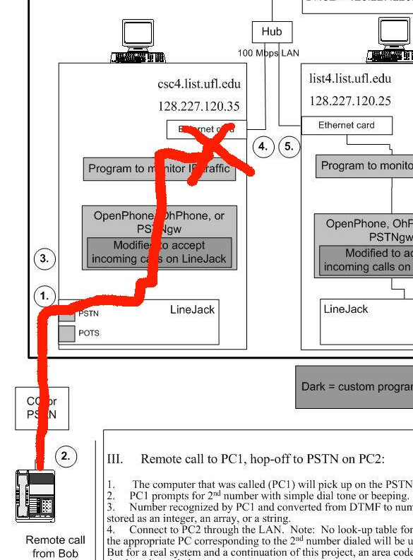
Appears to fail here
Actually fails here
MS-DOS> pstngw -q 355c047e 128.227.120.25 -t -t -t -o pstntrc3.txt --no-gatekeeper -i 128.227.120.35 --collect
MS-DOS> pstngw -q 355c0410 128.227.120.35 -t -t -t -o pstntrc3.txt --no-gatekeeper -i 128.227.120.25 --collect
s/n: 355c047e
s/n: 355c0410
[fig. 3] PSTNgw failing to transfer H.323 call to PSTNgw on the other PC

Planned steps for finding a solution and fixing the problem
Quickest and easiest way to fix the problem is listed first and then the more difficult and so forth.

Email the OpenH323 mailing list
A detailed email was sent to the OpenH323 community, but unfortunately it did not have any responses. Please see Appendix B for the email. Maybe the details should have been hidden. Ramya did this and obtained the following response [5]:

“if you run a regular h323 endpoint(openphone) on PC2,
are you able to receive the call from gateway? This is something
I would try first.
Another approach I would try is running, run Openphone
on some PC, call thru the gatekeeper, the gateway running
in PC2, see whether you are able to make outbound call.
/Sridhar”

Unfortunately, we have already tried the first suggestion in Phase II. And as for the second suggestion, the gatekeeper available to us is not possible to make an outbound call. We are not using a gatekeeper.

For making an outbound call, that was already thought of and is on the list below.

Research the internet for examples
No examples could be found our application and our type of VoIP system. It may have bee done before, but it was not documented or available.

Determine if the correct LineJACK driver from Quicknet was installed
Problem could be a driver and OpenH323 library interaction problem. Maybe the PSTNgw program was developed for an older driver and does not work with the newer LineJACK driver from Quicknet’s website. See if anyone on the OpenH323 mailing list has a LineJACK driver that works with the PSTNgw program.

No drivers for LineJACK in Windows 98 are available from the OpenH323 website and searching on the internet for a current driver has been unsuccessful.

Test PSTNgw with a incomnig H.323 call from OpenPhone
Try to invoke a H.323 from OpenPhone to the PSTNgw and thus working the system the other way around. This would be picking up where the big red ‘X’ left off and testing PSTNgw to see if accepts H.323 calls from another program. Of course, the PSTNgw program is still in need of programming since it cannot transfer a H.323 call. But this could help in seeing if it is failing at two points (accepting PSTN calls and accepting H.323 calls) or just one point (accepting PSTN calls).

Under VC++, compile PWLib, OpenH323, and PSTNgw with no modifications
Just making the source files compile is a project in itself. Two auxiliary programs are need when compiling, one is called Bison. If compiling the libraries, it may be wise to switch to “static” libraries since multiple versions of the library will be made and dynamically linked libraries seem to cause problems for most hobbyists using the OpenH323 source code.

Compile with modifications under VC++

Add to code so trace (debug output file) will output even more

Obtain the latest LineJACK driver (ixjwin32.cxx) file from the CVS repository and compile into the OpenH323 library.

Test on Linux with lastest LineJACK driver
Driver for the LineJACK card under Linux is available on the OpenH323 and is most likely more current or more interoperable with the OpenH323 programs.

Start programming: Modify code and debug all the files on Windows

Communications Lab - Testing H.323 call to PSTNgw

Results – success [fig. 4]
From the list of alternatives for fixing the problem, this was the most promising. The program OpenPhone would make a H.323 call to the other computer running PSTNgw that would dial out on the PSTN. Essentially, this method is testing the system in from the middle and working out to the PSTN [fig 4]. If it were a bridge, it would be like starting to build the bridge from the middle above the water and working to land.

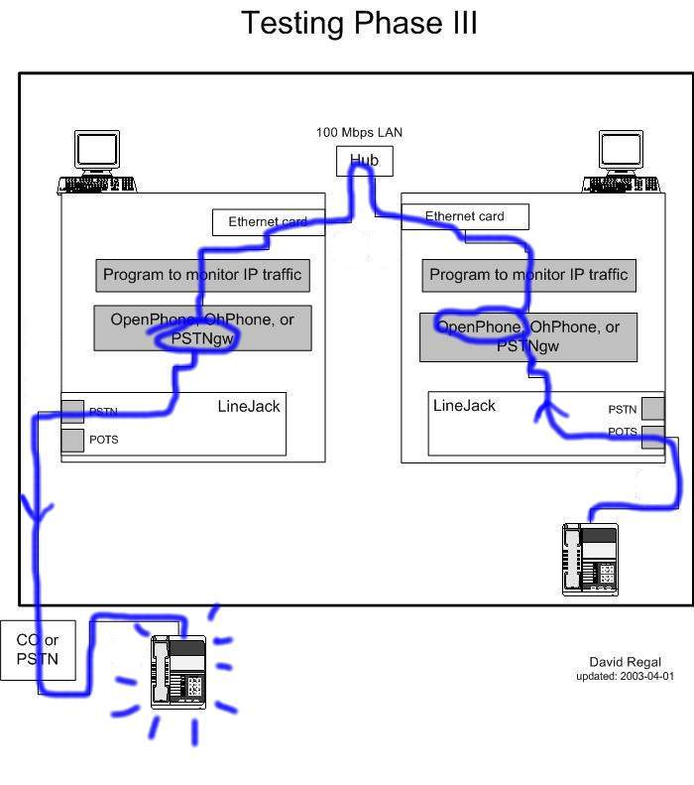
PSTN
MS-DOS> pstngw -q 355c047e 128.227.120.25 -t -t -t -o pstntrc3.txt --no-gatekeeper -i 128.227.120.35
OpenPhone >> Make call >>
Address: 128.227.120.35
Gateway: 128.227.120.35
[fig. 4] PSTNgw accepts H.323 calls and dials out

OpenPhone could transfer a H.323 call to the PSTNgw program. PSTNgw would accept the call and allow a phone number to be dialed out. This means that the PSTNgw can receive a H.323 call but cannot generate one.

Theory why PSTNgw fails on incoming PSTN calls – Centrex phone system
From looking at the trace for the failed system of Phase III [fig. 3], I began to suspect that the phone system at the University of Florida (UF) may be a problem. At the lab, the phone line that the computer is attached to does have a 7-digit outside number, but it is a switched phone system because when dialing out, you have to press “9” to get an outside line. PSTNgw works fine for calling out; probably because the switching function of the UF phone network has already taken place after “9” is pressed. But for incoming calls, the switching (or signaling) takes place seconds after the PSTNgw program picks up the call.

According to a professor, UF has a Centrex phone system. All of the switching functions are done off-site at the telephone company BellSouth. Looking into Centrex phone systems, the Direct Inward Dialing (DID) feature may be the cause of the problem. DID means someone calling the university can simple enter a 7-digit number and reach a certain department, instead of dialing a main number and entering an extension. Once the call is connected, it may be trying to off-load the circuits through circuit switching or software switching. Or it is possible the Centrex phone system constantly sends signaling for control of the phone lines that is causing interference. More information was sought on UF’s telephone infrastructure, but a technician in UF’s Telecomm Service Department could not be reached.

Another possibility is the LineJACK cards are too sensitive. The switching of incoming telephone calls might be causing it to detect a false “wink.” Basically, a “wink” is signal detected by the PSTNgw program when a remote caller hangs up. Or the cause could be from improper programming of the LineJACK’s driver. The conclusion was to test the system at a place where no need to press “9” to get an outside line, for instance, at any house or ordinary apartment.

Testing the system at an apartment

Testing PSTNgw to OpenPhone
After setting up the system of two PCs, two monitors and hub at the apartment, the theory of the UF switching problem was ready to be tested. At first, PSTNgw seem to have the same apparent problem as in the Lab, saying “failed at transferring call” but this was because of a networking problem. An Ethernet cable had accidentally been left in the “uplink” port of the hub. It was left there from when the system was connected to UF’s network. Since all of the downloads and updates have been done, we won’t be using the Internet anymore so no need for an uplink. Even though the system had to be moved, using the Lab was helpful because of the high-speed Internet. From the Lab, we downloaded all the necessary OpenH323 programs, and updated Windows 98 in a matter of minutes.

Results – success [fig. 5]
Once the Ethernet cable was plugged into a valid port on the hub, the PCs where networked properly and the PSTNgw call to OpenPhone was successful. All present were very happy to see Phase II working.

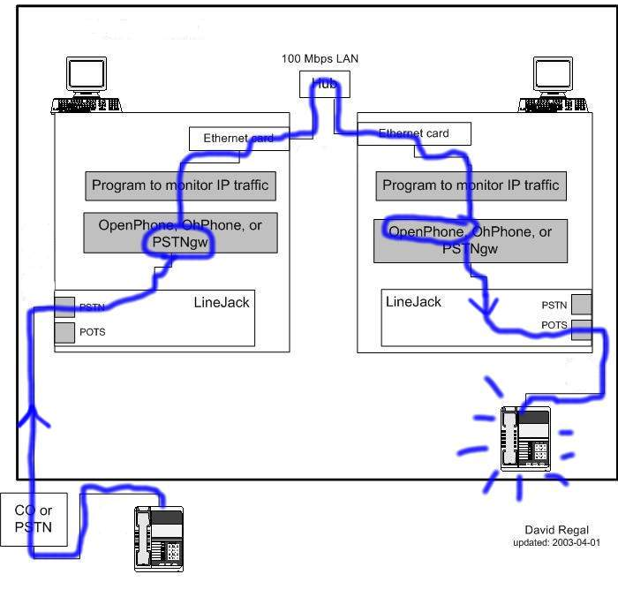
PSTN
MS-DOS> pstngw -q 355c047e 128.227.120.25 -t -t -t -o pstntrc3.txt --no-gatekeeper -i 128.227.120.35
OpenPhone running
[fig. 5] Phase II: Incoming PSTN call converted to H.323 and transferred successfully

Conclusion
This means Phase II does work without need modification [fig. 5] and communications lab does create problem for incoming PSTN calls. Knowing that the PSTNgw program can both accept PSTN calls and H.323 calls, the next step is to test Phase III. If this were a bridge over water, both sides have been built half-way, but started at different points on the river. Each half is hanging over the water and we only need to move them together.

Next step – move to a place with two phone lines
One problem with the apartment, it only has one phone line. Two phone lines are needed - one for the incoming call and another for the outgoing call. Luckily, one of the members of our group lives at a house with two phone lines.

Why not separate the PCs?
An alternative to moving the computers is to give them access to the Internet and public IPs (or figuring out how NAT works with PSTNgw). Even though the system is capable of doing this, we want to keep the PCs together so it would remain a simple LAN. When the project is successful in this configuration, then the next step is to test it using Internet.

If the PCs are separated and the Internet is used to test them, many issues arise. In our LAN, we have a controlled environment ideal for testing. Also, it is easier to operate because both computers are in one room (no need for traveling or synchronizing actions of the people operating the programs). Also with a 100 Mbps hub and static IPs, we do not have to worry about NAT, security, or bandwidth being pinched.

Testing at a house with 2 phone lines

Testing PSTNgw to PSTNgw
For notation, the names jack 1 and jack 2 are used as names for the two phone lines. Testing for the first night, the whole group of five was present. Unfortunately, we spent most of the night watching the black MS-DOS screen full of white text telling us of failed calls. Unlike a cheering on a sports team, the computers do not play better even if fans are present

Results –fails to dial out 90% of the time [fig. 6]
On the first night, only 2 successful phone calls where made in over a couple hours of testing. On a second night of testing, 3 successful calls were made. The success rate of 10% is unacceptable.

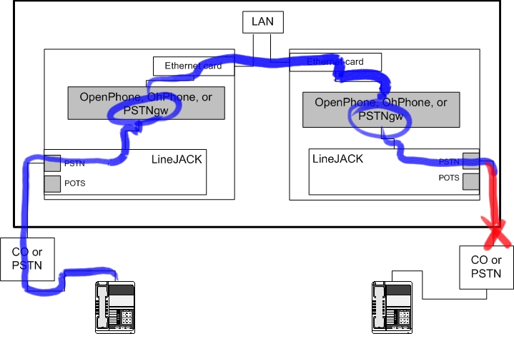
[fig. 6] Incoming PSTN call converted to H.323 and transferred successfully, but 90% of calls fail to dial out

Testing OpenPhone to PSTNgw
Using OpenPhone to spawn a H.323 call to the PSTNgw program, it only work about 60% for dialing out on jack 2 and about 30% for jack 1.

Results – also fails to dial out [fig. 7]
When the OpenPhone works, so does the PSTNgw to PSTNgw so it seems the interference fades and a window opens up so a streak of successful calls can be made.

If it is the phone line, and not the PSTNgw program, then using OpenPhone shouldn't work either. OpenPhone didn't work, so it is the phone lines. At the apartment, OpenPhone always worked.

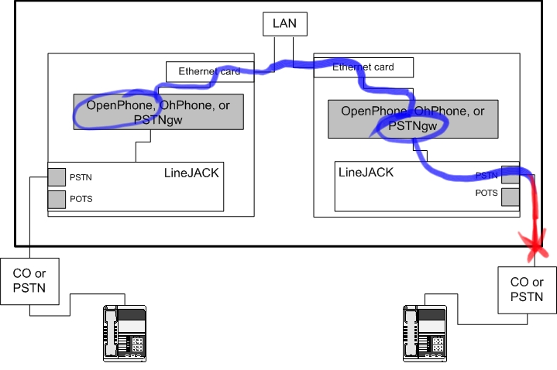
[fig. 7] PSTNgw accepts H.323 calls but fails to dial out

Conclusion – PSTNgw program works but not with AM interference
Having shown that the phone line is causing the problem, a new place would be need for testing the VoIP system. Having the OpenPhone program fail was good news and gave hope that the system would work eventually.
Jack 2 seems to accept phone calls better, recognize digits pressed for the second number better, and make outgoing calls better than jack 1. Comparing the noise (sounds like cross-talk), jack 2 has less than jack 1. To find out if there is noise on the phone line, press a phone button and listen. Wanting to figure out more about this background noise heard on the line we turned on a radio, turned the knob slowly, listened and found that it is an AM station, 1230 kHz. This channel is ESPN Radio, guys talking about sports, and we have coined the phrase "sports-talk cross-talk." There was another AM radio talk show, female voices, on the lines but it was too faint to distinguish.

The LineJACKs probably do not have a filter for AM stations and are sensitive to this noise. This could be comparable to how the powerline networking technology, HomePlug, is sensitive to hair dryer or a vacuum cleaner. The interference wipes out the DTMF signal and also detects a false “wink” when dialing out [fig. 8]. Both in Gainesville, the house is located only 10 miles NW from the apartment. There is no interference at the apartment. Maybe the layout of the phone lines at the house create act as an antenna tuned for these AM frequencies.

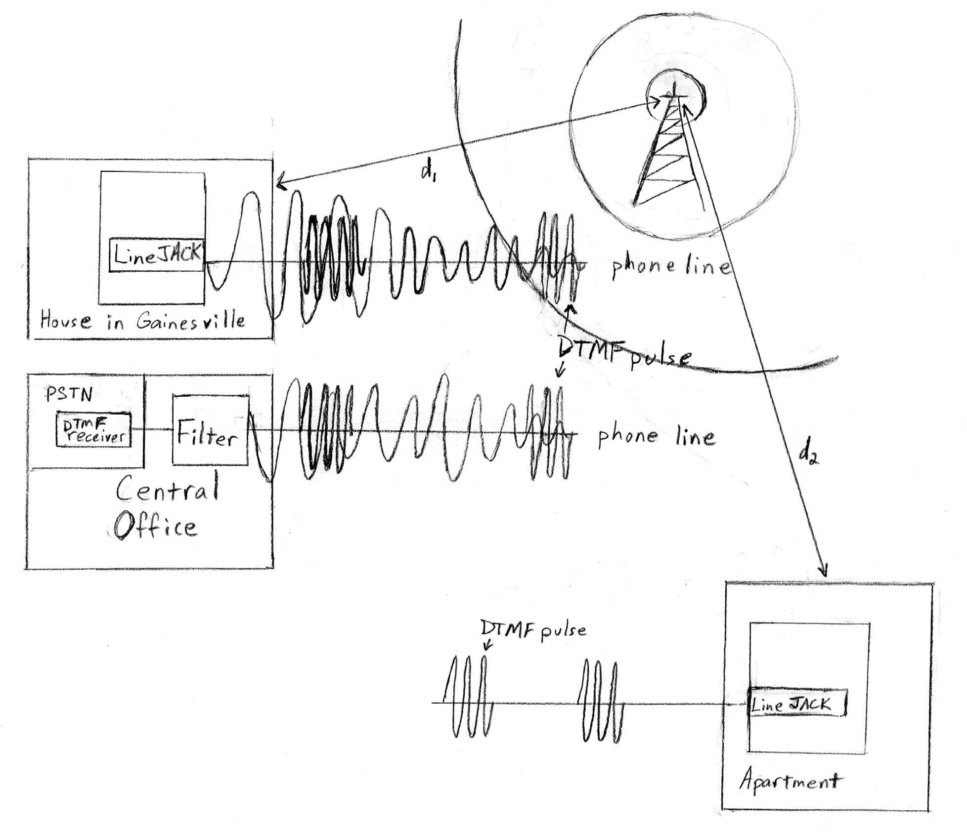
House: DTMF pulses are lost in the interference. Explains why digits pressed were only recognized half the time for jack 2 and not at all for jack 1.
CO: DTMF pulses are received.
Apartment: Phone lines are shield from AM radio interference and do not act as an antenna.
AM radio 1230 kHz
[fig. 8] AM interference and theory of why it interferes

Back to the apartment – testing with 2 phone lines
An additional phone line was installed at the apartment. Both of the phone lines do not have any noise detectable by the human ear.

Testing PSTNgw to PSTNgw
A cell phone was used to make calls into the apartment. For the second number, only 10-digits (e.g. 333 432-1111) can be entered so only local calls could be made.

Results – success [fig. 9]

Tested successfull several times – PSTNgw is bidirectional
If the proper steps are followed for using the program, both instances of PSTNgw will remain stable on the two PCs and calls can be both ways. This is good to see it is truly bidirectional.

Soft conversation - Volume needs to be turned up
Even though the person called could barely hear the caller, the person called could be heard well. Maybe a PSTNgw options for volume control exists, but we do not know of one. Maybe the echo cancellation option has something to do with the volume being soft.

Volume control was found. Use the “- - playgain” option even though the help output claims it’s for a VoiceTronix card. The syntax is “ - - playgain [NN]” where nn is an integer from 0 to 100. For 100%, volume type:

pstngw.exe -q 355c047e 128.227.120.35 -i 128.227.120.25 --playgain 100

PSTNgw will lock-up if ”#” not pressed
If the caller hangs up after starting to enter the second number in and before pressing the “#” key, the PSTNgw program will stop working and need to be restarted.

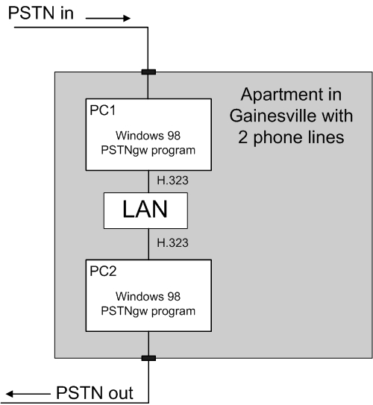
[fig. 9] Phase III: PSTNgw Success

Conclusion –need clean phone lines

No noise

No switching

Sensitivity to the above may be a programming problem or LineJACK hardware problem
To test this, try using the Linux version on PSTNgw. If it the program works properly in Linux, then it is a software problem with the Windows version.

Future plans

Use this VoIP system to test different codecs
The LineJACK card has many different voice compression codecs that can be used. Testing different codecs the quality vs. bandwidth can be compared on a live system. For example, the option for selecting preferred codecs is done by using the PSTNgw option “-P G.711-uLaw-64k{sw}”

List of codecs available (sw = software, hw = hardware):
- G.723.1A(6.3k){hw} <1>
- G.723.1A(6.3k)-Cisco{hw} <2>
- G.723.1{hw} <3>
- G.728{hw} <4>
- G.711-ALaw-64k{hw} <5>
- G.711-uLaw-64k{hw} <6>
- GSM-06.10{sw} <7>
- G.711-uLaw-64k{sw} <8>
- G.711-ALaw-64k{sw} <9>

Purchase credits and test InternetSwithboard
A system available from Quicknet, an account can be set up so an H.323 call can be routed to just about anywhere in the world. Using the LineJACK, PhoneJACK, or even a microphone and speakers, H.323 calls can be placed to this server program and routed to different countries. Like a phone card, minutes are purchased but at lower rates than a phone company.

Seperate the computers and test across the Internet

Compiling and modifying the OpenH323 souce code

Current Versioning System (CVS) repository can be used
To have the latest changes for the OpenH323 programs and possibly fix a bug, the code from the CVS repository can be used. However, this code has not been tested for stability and even if one bug is fixed, there may be other problems caused by using this untested code.

One cpp file of interest is the ixjwin32.cxx file – the driver for the LineJACK card – found in the source files for the OpenH library. Having this file updated and fully working may make for a stable LineJACK that can tolerate some noise.

Add more digits
With the PSTNgw program used, it only accepts 10-digits for making an outgoing PSTN call. This means no long distance phone calls can be made. For that, you would need eleven digits (e.g. 1 444 333-2222). Not being able to call long-distance makes sense because the point is to save on long-distance charges. This works fine in the US, but would not work with other countries that may have more than 10 digits for dialing.

A robust system with a way to map telephone numbers to IP addresses is needed. This system works by binding H.323 calls to be transferred to only one IP. If this is to be a practical system, the IP called should be determined by the phone number that is to be dialed out. And the H.323 call is appropriately routed through the Internet to the hop-off point thus avoiding long-distance charges. Perhaps the gatekeeper (OpenH323’s opengk is very basic) would serve this function; however, it seems this is where a SIP based system would do better.

Implementing in other countries
It is not known if the signaling features (tones, ringing, busy signal, etc) that are built into the LineJACK chips will work with other countries telephone system. If not, then programming will be necessary for adapting to the appropriate telephone system.

Converting to Linux

Same OpenH323 programs available
For the PSTNgw program, the syntax is only slightly different. Instead of using the serial number after the “-q” options, the Linux mounting point is used. So the syntax is “-q /dev/quicknet” instead of “-q serialNo.”

Also the OpenPhone program is not available for Linux. So for generating a H.323 call to the PSTNgw program, OhPhone should be used.

Linux version of PSTNgw program is possibly more stable
With the Windows version, if the caller hangs up before pushing “#” key, the PSTNgw program will stop working and will need to be restarted. If Linux was used, logging into the computer remotely and restarting the program would be easier. And quite possibly, may not be necessary if the Linux version is more stable.

Using Linux version may fix sensitivity problem
If the sensitivities to noise in the phone line caused from software, then using the Linux programs may eliminate the problem.

Converting to a SIP based system
Session Initiated Protocol (SIP) is a replacement for the H.323 format but can also be used in conjunction. A SIP based VoIP system may provide more control so billing, transferring and monitoring calls, and signaling features can be used.

More PCs required
The SIP based system has more divisions of the tasks and uses more servers. Even though they have different names, many of the servers have their equivalent in the H.323 system.

Try to use the program VOCAL www.vovida.org [6]

Conclusion

OpenH323 is a solution to a PSTN to PSTN VoIP system
Despite having sensitivities to noise in the phone line, the combination of a LineJACK and the PSTNgw program from OpenH323 provides a complete VoIP system. Having access to the source code of the OpenH323 programs, and availability in both Windows and Linux, many possibilities exist for further testing and modification. Starting with this solid base of C++ source code, many other projects and VoIP applications are possible. However, for commercial applications, there are restrictions that the library files can not be used.

Successful testing of the Phase III, the final phase, happened only three days behind schedule and five days before this report was due. The working system is at the apartment and can be demonstrated anywhere in Gainesville. Feeling inspired, a pictorial view of Voice over IP [fig. 10] was drawn that day.

PSTNgw performs all of the required specifications
No programming is needed. When the research was being done, it was not clear how complete the PSTNgw program was and how many features it had. With LineJACK and PSTNgw, anyone can have a fully functional VoIP system by simply downloading the OpenH323 suite and properly installing them.

Business theory and lessons learned
When this project was started, it was not known if the OpenH323 programs would do all the functions required for this VoIP application. While researching the OpenH323 programs, it was never clear which programs did what and with what hardware they worked with. There were no examples or significant documentation on the web for an application like this so this was unknown territory.

Like many things, it is usually easier to research, and plan than it is to actually implement the system. With the large amount of money invested in the two LineJACK VoIP cards, having a successful project by the end of the semester was very important and provided tense motivation. Even if hours of research has been done, phone calls made, email to the OpenH323 written, and a schedule made, this project was never certain to work. Only as you go into the project, with hands-on implementation, can you see if it will work.

This served as an important lesson in the real world of business and will help if we are working in research and development department in a corporation. Provided with money from an investor in a new technology, and the investor asks if the project could be done, it is similar to asking an adventurer to describe if there are trees, buildings, or fields in a landscape hidden in fog. This is a new territory, so even though the adventurer increases the chance of success by making plans, sending out probes, and researching, only until the adventurer walks into the fog can the landscape be seen. Nothing is certain until the project is complete. But if progress is to be made, someone has to walk into the fog.

Acknowledgements

Dr. H. Latchman
Thank you for providing funding for the two LineJACK cards, use of the Communications Lab, and two complete PCs with monitors.

PhoniGators team
- Ramya Dharshini Chandrasekhar – hardware set-up, email OpenH323.org, AudioCodes research
- Janardhan Lavakumar – car for moving PCs, PSTNgw testing, formatting IEEE
- Harsha Munikoti – Alternatives to LineJACK research, hardware set-up
- Sajan Peter –PhoniGators website http://plaza.ufl.edu/sajanwp/ , AudioCodes research
- David Regal – project leader, diagrams, documenting PSTNgw, networking

Professors on my Highest Honors (Summa Cum Laude) committee
Dr. H. A. Latchman - EE department
Mathematical systems theory, control systems, communication theory, data
communications networks, multimedia information systems
Dr. J. G. Harris - EE department
Analog and digital signal processing, VLSI, adaptive and neural systems
Dr. D. W. Mikolaitis - ME department
Fluid mechanics, combustion theory, applied mathematics

Dr. T. E. Bullock – EE department
Mathematical systems theory, filtering, digital control with microprocessors, programming

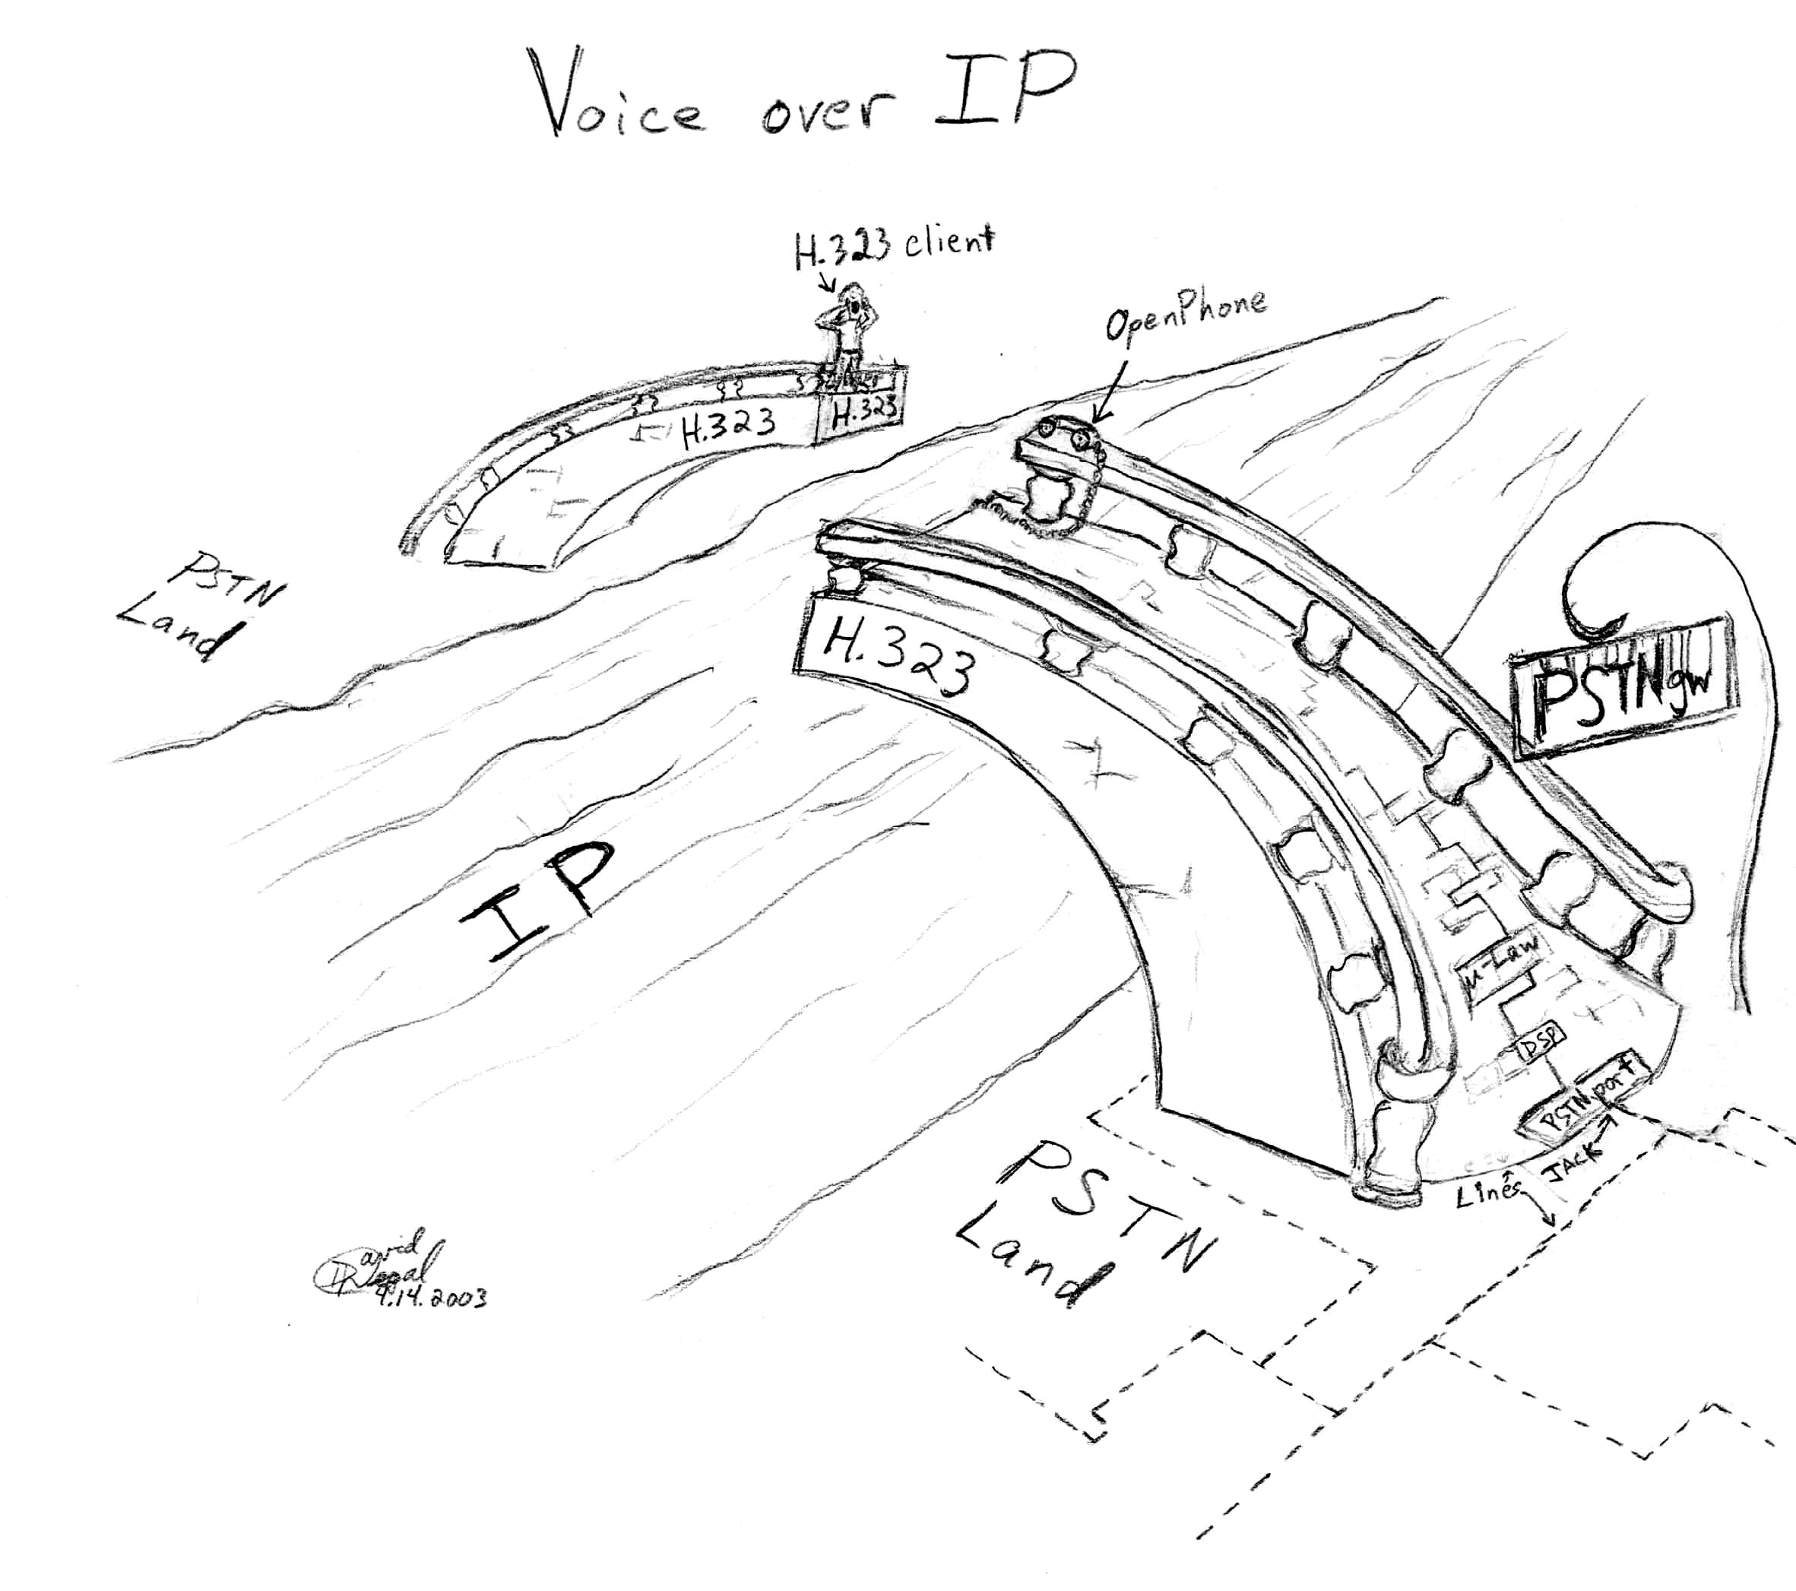
[fig. 10] An analogy “Voice over IP”

Appendix A – email about POTS vs PSTN port on LineJACK, modem/sound card alternative

My email
Subj: | PSTNgw: Just use LineJack. Or is modem/sound card possible?
Date: | 2/17/2003
To: | openh323@openh323.org

OpenH323 developers,
I and 4 other students are working on a class project at the University of Florida.
I've been to the website, studied the OpenH323 programs source code and readme text files and done other web researching. The OpenH323 suite seems the best way to go for a VoIP system, but I still have some questions.
We want to implement a remote call-in system through a standard US telephone system.
1.) We want to keep cost down and were considering alternatives to the LineJack.
a.) I've read through the archives of the mailing list. I learned the system be done with a modem and sound card and modifying the OpenH323 software.
But has any substantial work been started that we could build on?
b.) The PhoneJack is half the price of the LineJack, but only has a POTS line and no PSTN line.
Is there any way to modify the PSTNgw program to use the PhoneJack as a gateway?
3.) In the OpenH323 PSTNgw program version 1.2.1 for Windows, the readme.txt file has a "-q" option for the Quicknet cards. On line 25 it says "-q --quicknet dev : Use Quicknet LineJACK." But in the I only see the "-v" options (for Voicetronix card) being used for the gateway. I know the readme file was written for a Voicetronix Quickstart, but I want to make sure the system can be done with the PhoneJack.
a.) Can I just use the LineJack to implement the PSTNgw? Or do I need the Voicetronix card also?
b.) What's the command for using LineJack as the PSTNgw?
4.) If I buy the LineJack, is there some proprietary software that comes with it that can be used for the remote call-in system?
Keep up the good programming,
David Regal
Electrical and Computer Engineering student, UF

Response 1

Message: 9
Date: Tue, 18 Feb 2003 14:33:34 +1100
From: Equivalence Support <equival@equival.com.au>
To: openh323@openh323.org
Subject: Re: [OpenH323]PSTNgw: Just use LineJack. Or is modem/sound card possible?
Organization: Equivalence Pty. Ltd.
Reply-To: openh323@openh323.org
On Mon, 17 Feb 2003 20:12:55 EST
Skurfur@aol.com wrote:
> We want to implement a remote call-in system through a standard US
> telephone system.
>
> 1.) We want to keep cost down and were considering alternatives to the
> LineJack.
>
> a.) I've read through the archives of the mailing list. I learned the
> system be done with a modem and sound card and modifying the OpenH323
> software.
> But has any substantial work been started that we could build on?
I remember someone doing work on this. But can't say how far it got.
> b.) The PhoneJack is half the price of the LineJack, but only has a
> POTS line and no PSTN line.
> Is there any way to modify the PSTNgw program to use the PhoneJack
> as a gateway?
Um, no. What is the point?
> 3.) In the OpenH323 PSTNgw program version 1.2.1 for Windows, the readme.txt
> file has a "-q" option for the Quicknet cards. On line 25 it says "-q
> --quicknet dev : Use Quicknet LineJACK." But in the I only see the "-v"
> options (for Voicetronix card) being used for the gateway. I know the readme
> file was written for a Voicetronix Quickstart, but I want to make sure the
> system can be done with the PhoneJack.
> a.) Can I just use the LineJack to implement the PSTNgw? Or do I need
> the Voicetronix card also?
Yes.
> b.) What's the command for using LineJack as the PSTNgw?
-q as documented
> 4.) If I buy the LineJack, is there some proprietary software that comes
> with it that can be used for the remote call-in system?
Depends on exactly what you mean by "remote call-in system".
Maybe a bit more explanation?
----------
Robert Jongbloed Equivalence Pty. Ltd.
Architect Open Phone Abstraction Library (OPAL) & OpenH323
Open Source Telecommunication Protocol Libraries

Response 2

Forwarded Message:
Subj: | Re: [OpenH323]PSTNgw: Just use LineJack. Or is modem/sound card possible?
Date: | 2/18/2003 12:46:36 AM Eastern Standard Time
From: | roger@desalis.gen.nz
To: | skurfur@aol.com
Sent from the Internet (Details)

Further to Robert Jongbloed's response....
> b.) The PhoneJack is half the price of the LineJack, but only has
> a POTS line and no PSTN line.
>
> Is there any way to modify the PSTNgw program to use the
> PhoneJack as a gateway?
>
No. (Nothing to do with modifying software, the card won't
work the other way round...)
The difference between FXO and FXS. Foreign eXchange Office
(ie line to telephone exchange) and Foreign eXchange Station
(ie connects to the telephone handset.)
A phone line interface is not bi-directional. The phone exchange
provides power (48V), the handset receives it. So the phonejack
card generates 48V to connect a phone to, to you cannot connect
a 48V generator to the exchange (itself generating 48V).
Hence the difference between FXS and FXO. Why is the line
jack more expensive? It just is, welcome to the world of
telephony, where the cost has nothing to do with the price
(kit, calls, interface cards, bills from the phone company).
>Keep up the good programming,
> David Regal
> Electrical and Computer Engineering student, UF
>
--
\_ Roger De Salis rdesalis@fx.net.nz
</' FX Networks +64 25 481 452
/) Wellington, New Zealand roger@desalis.gen.nz
(/
` DSL - the 56k modem technology of 2004

Response 3
Message: 4
Date: Tue, 18 Feb 2003 15:19:07 +1300 (NZDT)
From: derek@indranet.co.nz
To: openh323@openh323.org
Subject: Re: [OpenH323]PSTNgw: Just use LineJack. Or is modem/sound card
possible?
Reply-To: openh323@openh323.org
Hi,
There are no reasonable alternatives to the linejack.
using a modem etc is not feasible for you in the available time frame.
Forget using a modem.
yes, you could use the phonejack as a gateway,
you would then use the ohphone program. When a call comes in, the phone
plugged into the pots port would ring.
However, I think you are asking, could the phonejack be connected to the
standard telephone network. No.
PSTNGw cannot be used with a phonejack - forget this idea.
The voicetronix card is alternative card to the linejack. However, it is
more expensive than the linejack. AND, the voicetronix don't do g723.1
You could find a different card (not supported by openh323) and use that.
However, you would then have to write heaps of code to get it to work.
You don't have time to write all the necessary code.
PSTNGw will work with either the voicetronix, or linejack card.
My preference is the linejack card.
Derek.
========================================================
On Mon, 17 Feb 2003 Skurfur@aol.com wrote:
> OpenH323 developers,
> I and 4 other students are working on a class project at the
> University of Florida.
>
> I've been to the website, studied the OpenH323 programs source code
> and readme text files and done other web researching. The OpenH323 suite
> seems the best way to go for a VoIP system, but I still have some questions.
>
> We want to implement a remote call-in system through a standard US
> telephone system.
>
> 1.) We want to keep cost down and were considering alternatives to the
> LineJack.
>
> a.) I've read through the archives of the mailing list. I learned the
> system be done with a modem and sound card and modifying the OpenH323
> software.
> But has any substantial work been started that we could build on?
>
> b.) The PhoneJack is half the price of the LineJack, but only has a
> POTS line and no PSTN line.
> Is there any way to modify the PSTNgw program to use the PhoneJack
> as a gateway?
>
> 3.) In the OpenH323 PSTNgw program version 1.2.1 for Windows, the readme.txt
> file has a "-q" option for the Quicknet cards. On line 25 it says "-q
> --quicknet dev : Use Quicknet LineJACK." But in the I only see the "-v"
> options (for Voicetronix card) being used for the gateway. I know the readme
> file was written for a Voicetronix Quickstart, but I want to make sure the
> system can be done with the PhoneJack.
> a.) Can I just use the LineJack to implement the PSTNgw? Or do I need
> the Voicetronix card also?
> b.) What's the command for using LineJack as the PSTNgw?
>
> 4.) If I buy the LineJack, is there some proprietary software that comes
> with it that can be used for the remote call-in system?
>
> Keep up the good programming,
> David Regal
> Electrical and Computer Engineering student, UF
>
>
--
Derek Smithies Ph.D.
IndraNet Technologies Ltd.
Email: derek@indranet.co.nz
ph +64 3 365 6485
Web: http://www.indranet-technologies.com/

Appendix B – long email about switching problem
Subj: | Problem: pstngw fails to call to another pstngw. LineJACK, Windows98.
Date: | 3/24/2003
To: | openh323@openh323.org

Hello,
I'm working on a VoIP project for a professor in telecommunications and really want this to work since he spent a lot of money for the 2 cards.
Problem: Calling in from an outside line, pstngw collects number but then fails to connect the H.323 call to other PC running pstngw. From trace, "Line Monitor: Call from Internet LineJACK (355C047E)-1 to 128.227.120.25 failed."
Hardware:
2 networked PCs with static IPs.
2 LineJACK cards
OS:
Windows 98se
What I’ve done__________________________________________________
Thinking it might be a problem with a false "OpalIxJDevice::IsLineDisconnected" on the LineJACK, I’ve checked the CVS repository for the latest version of the ixjwin32.cxx, which is version 1.113. In the stable release for Windows of OpenH323 has this latest version and I'm running it. Also, I checked the OpenH323 mail list discussion archives. I found out others have had this problem and asked questions but I didn’t find any answers, so I am writing the OpenH323 mailing list now.
The system:
Home telephone1 -- (PSTN) -- LineJACKs/n:355C047E -- PCcallIn -- Ethernet:128.227.120.35 -- (LAN) --
-- Ethernet:128.227.120.25 -- PCcallOut -- LineJACKs/n:355C0410 -- (PSTN) -- Home telephone2
On PCcallIn, pstngw.exe command:
pstngw -q 355c047e 128.227.120.25 -t -t -t -o pstntrc3.txt --no-gatekeeper -i 128.227.120.35 --collect
On PCcallOut, pstngw.exe command:
pstngw -q 355c0410 -t -t -t -o pstntrc3.txt --no-gatekeeper -i 128.227.120.25
After the programs are ready (ie “waiting for incoming calls”), I dial PCcallIn (from an outside PSTN phone). I dial a second number followed by #, but then the call fails. It fails to connect the H.323 call to pstngw program running on PCcallOut. PCcallOut does not register anything. Screen remains at "waiting for incoming call." And the output of the trace on PCcallOut has nothing significant but just remains in the loop “Line Monitor, start of loop”
Level 3 trace output on PCcallIn:
0:00.092 PSTNGw osutils.cxx(798) PSTNGw Version 1.2.2 by OpenH323 Project on Windows 98 (v4.10.2222-i586) at 2003/3/22 21:30:43.240
0:00.100 PSTNGw h323ep.cxx(837) H323 Created endpoint.
0:00.104 PSTNGw main.cxx(436) GatewayEndPoint Jitter buffer is 50 to 250 ms
0:00.183 PSTNGw h323ep.cxx(1218) H323 Started listener Listener[ip$128.227.120.35:1720]
0:00.186 H323 Cleaner h323ep.cxx(727) H323 Started cleaner thread
0:00.202 H323 Listener:7c6e10 transports.cxx(1280) H323 Awaiting TCP connections on port 1720
0:00.204 PSTNGw ixjwin32.cxx(461) xJack Opening IxJ device "355c047e"
0:00.215 PSTNGw ixjwin32.cxx(548) xJack Opened IxJ device "Internet LineJACK (355C047E)" version 6.1.208
0:00.224 PSTNGw main.cxx(540) ep Initialise SetLineOnHook true
0:00.232 PSTNGw h323caps.cxx(1616) H323 Added capability: G.723.1A(6.3k){hw} <1>
0:00.232 PSTNGw h323caps.cxx(1616) H323 Added capability: G.723.1A(6.3k)-Cisco{hw} <2>
0:00.233 PSTNGw h323caps.cxx(1616) H323 Added capability: G.723.1{hw} <3>
0:00.233 PSTNGw h323caps.cxx(1739) H323 Found capability: G.723.1A(6.3k){hw} <1>
0:00.234 PSTNGw h323caps.cxx(1739) H323 Found capability: G.723.1{hw} <3>
0:00.234 PSTNGw h323caps.cxx(1616) H323 Added capability: G.728{hw} <4>
0:00.235 PSTNGw h323caps.cxx(1616) H323 Added capability: G.711-ALaw-64k{hw} <5>
0:00.235 PSTNGw h323caps.cxx(1616) H323 Added capability: G.711-uLaw-64k{hw} <6>
0:00.246 PSTNGw h323caps.cxx(1616) H323 Added capability: GSM-06.10{sw} <7>
0:00.246 PSTNGw h323caps.cxx(1616) H323 Added capability: G.711-uLaw-64k{sw} <8>
0:00.247 PSTNGw h323caps.cxx(1616) H323 Added capability: G.711-ALaw-64k{sw} <9>
0:00.247 PSTNGw h323caps.cxx(1616) H323 Added capability: UserInput/hookflash <10>
0:00.247 PSTNGw h323caps.cxx(1616) H323 Added capability: UserInput/basicString <11>
0:00.248 PSTNGw h323caps.cxx(1616) H323 Added capability: UserInput/dtmf <12>
0:00.248 PSTNGw h323caps.cxx(1616) H323 Added capability: UserInput/RFC2833 <13>
0:00.255 PSTNGw transports.cxx(1664) H323UDP Binding to interface: 128.227.120.35:1031
0:00.257 PSTNGw transports.cxx(969) H323 H323Transport::Close
0:00.264 LineMonitor:007c60e0 main.cxx(952) PSTNGW Line monitor thread for Internet LineJACK (355C047E)-1 started
0:00.764 LineMonitor:007c60e0 main.cxx(957) PSTNGW Line Monitor, start of loop
...omitted loops...
0:13.269 LineMonitor:007c60e0 main.cxx(957) PSTNGW Line Monitor, start of loop
0:13.769 LineMonitor:007c60e0 main.cxx(957) PSTNGW Line Monitor, start of loop
0:13.769 LineMonitor:007c60e0 main.cxx(959) PSTNGW Line Monitor, detected line is ringing
0:13.770 LineMonitor:007c60e0 main.cxx(975) PSTNGW Line Monitor. Call address 128.227.120.25
0:13.772 LineMonitor:007c60e0 ixjwin32.cxx(2040) xJack Stopping tones
0:13.772 LineMonitor:007c60e0 ixjwin32.cxx(2054) xJack Playing tone: 25 0 0 0
0:23.859 LineMonitor:007c60e0 ixjwin32.cxx(2040) xJack Stopping tones
0:23.860 LineMonitor:007c60e0 main.cxx(986) PSTNGW Line Monitor: Call from Internet LineJACK (355C047E)-1 to 128.227.120.25 failed.
0:24.365 LineMonitor:007c60e0 main.cxx(992) PSTNGW Line Monitor, Ringing stopped on deviceInternet LineJACK (355C047E)-1
0:24.869 LineMonitor:007c60e0 main.cxx(957) PSTNGW Line Monitor, start of loop
0:25.369 LineMonitor:007c60e0 main.cxx(957) PSTNGW Line Monitor, start of loop
...omitted loops...
0:56.379 LineMonitor:007c60e0 main.cxx(957) PSTNGW Line Monitor, start of loop
0:56.427 H323 Cleaner h323ep.cxx(1594) H323 Cleaning up connections
0:56.459 LineMonitor:007c60e0 main.cxx(1006) PSTNGW Line monitor thread for Internet LineJACK (355C047E)-1 stopped
0:56.472 PSTNGw ixjwin32.cxx(1140) xJack Stopping read codec
0:56.473 PSTNGw ixjwin32.cxx(1158) xJack Stopping write codec
0:56.476 H323 Listener:7c6e10 transports.cxx(1180) TCP Accept error:Socket closed or invalid
0:56.498 H323 Cleaner h323ep.cxx(1594) H323 Cleaning up connections
0:56.514 H323 Cleaner h323ep.cxx(737) H323 Stopped cleaner thread
0:56.519 PSTNGw h323ep.cxx(1594) H323 Cleaning up connections
0:56.519 PSTNGw h323ep.cxx(860) H323 Deleted endpoint.
I’ve tried both of the commands above without the “-i” option. Also, I have tried a pstngw-to-openphone. It doesn't work and says "Caller hung up" because it detects a "wink" on the incoming call even though it is still ringing. "netstat -a" on both computers doesn't show anything relevant.
I’ve tested the LineJACK cards with a OpenPhone-to-OpenPhone system and it works. So I know the 2 LineJACK cards are working and the 2 PCs are networked together correctly.
Questions:
1. Please, does anyone know how to make pstngw.exe to work so it will transfer the H.323 call to the pstngw running on the second computer (PCcallOut) and then hop-off to the PSTN? If yes, how?
2. Does somebody have some code to fix the pstngw problem?
3. If "yes" to above, would you provide it to me?
4. Are my 2 pstngw commands correct?
5. If "no" to above, what is the correct command for PCcallIn?
6. If "no" to (4.), what is the correct command for PCcallOut?
7. In the trace, right after pstngw on PCcallIn binds to IP:port, the next line says "H323Transport::Close." Maybe that is a problem. What is it closing?
Other than this, the programs seem to work well (OpenPhone, and PSTNgw). I appreciate the work done by the OpenH323 project, hope it continues, and I want to contribute by providing a report I am writing for implementing this system. First, I want to get it working.
David Regal
Undergraduate EE student
University of Florida

References

- From readme.txt for the OpenH323 pstngw program.
- Experimenting with New Methods in Voice over IP, http://www.linuxjournal.com/article.php?sid=5941
- Alternatives to LineJACK, February 16, 2003 Harsha Munikoti
- www.openh323.org
- Email response sent to Ramya Dharshini Chandrasekhar, March 25, 2003, Sridhar
- VOCAL from www.vovida.org

